CHAROTAR UNIVERSITY OF SCIENCE & TECHNOLOGY
DEVANG PATEL INSTITUTE OF ADVANCE TECHNOLOGY & RESEARCH
Department of Computer Engineering
Subject Name: Web Development Framework
Semester: III
Subject Code: ITEU204
Academic year: 2025-26 [ODD]

Practical File
No. | Aim of the Practical
1. | Initiate the “Project Title” by defining scope, key pages (min. 10), and layout  with HTML skeletons.  PROGRAM CODE:  1. Home page  <!DOCTYPE html>  <html lang="en">  <head>  <meta charset="UTF-8">  <title>ShopSphere</title>  <link rel="stylesheet" href="../css/homepage.css">  <link rel="stylesheet" href="https://cdnjs.cloudflare.com/ajax/libs/font-awesome/6.5.0/css/all.min.css">  </head>  <body>  <!-- Header -->  <header class="main-header">  <div class="logo">ShopSphere <span class="plus">Explore Plus </span></div>  <div class="search-bar">  <input type="text" placeholder="Search for Products, Brands and More">  <i class="fas fa-search"></i>  </div>  <div class="header-icons">  <a class="link" href="login.html">  <div class="icon-item ">  <i class="fas fa-user"></i>  <span>Login</span>  </div>  </a>  <a class="link" href="cart.html">  <div class="icon-item">  <i class="fas fa-shopping-cart"></i>  <span>Cart</span>  </div>  </a>  <a class="link" href="orders.html">  <div class="icon-item">  <i class="fas fa-box"></i>  <span>Orders</span>  </div>  </a>  <a class="link" href="wishlist.html">  <div class="icon-item">  <i class="fas fa-heart"></i>  <span>Wishlist</span>  </div>  </a>  <!-- Three Dots with dropdown -->  <div class="icon-item dropdown" id="menuToggle">  <i class="fas fa-ellipsis-v"></i>  <div class="dropdown-content right" id="dropdownMenu">  <a href="customerCare.html">Customer Care</a>  <a href="aboutUs.html">About Us</a>  <a href="contactUs.html">Contact Us</a>  <div style="display: flex; align-items: center; justify-content: space-between; padding: 10px 16px;">  <p style="margin: 0; font-size: 14px;">Dark Mode</p>  <label class="switch">  <input type="checkbox" id="darkToggle">  <span class="slider round"></span>  </label>  </div>  </div>  </div>  </div>  </header>  <!-- Category Menu Row -->  <section class="category-row">  <div class="category-item">  <img src="../images/grocery.jpg" alt="Grocery">  <a href="grocery.html">Grocery</a>  </div>  <div class="category-item">  <img src="../images/mobile.jpg" alt="Mobiles">  <a href="mobiles.html">Mobiles</a>  </div>  <!-- Fashion Category with Dropdown -->  <div class="category-item dropdown-category" id="fashionToggle">  <img src="https://img.icons8.com/color/48/clothes.png" alt="Fashion">  <p>Fashion <i class="fas fa-chevron-down small-icon"></i></p>  <div class="dropdown-menu" id="fashionMenu">  <a href="men.html">Men</a>  <a href="women.html">Women</a>  </div>  </div>  <!--<div class="category-item">  <img src="../images/electronics.jpg" alt="Electronics">  <a href="electronics.html">Electronics</a>  </div>-->  <!--<div class="category-item">  <img src="../images/appliances.jpg" alt="Appliances">  <a href="appliances.html">Home Appliances</a>  </div>-->  <div class="category-item">  <img src="../images/beauty.jpg" alt="Beauty">  <a href="beauty.html">Beauty</a>  </div>  <!--<div class="category-item">  <img src="../images/toys.jpg" alt="Toys">  <a href="toys.html">Toys and more</a>  </div>-->  </section>  <!-- Main Banner -->  <section class="main-banner">  <div class="slideshow-container">  <img class="slide" src="../images/banner1.jpg" alt="Slide 1">  <img class="slide" src="../images/banner2.jpg" alt="Slide 2">  <img class="slide" src="../images/banner3.jpg" alt="Slide 3">  <a class="prev" onclick="changeSlide(-1)">&#10094;</a>3  <a class="next" onclick="changeSlide(1)">&#10095;</a>  </div>  </section>  <!-- Product Section: Best of Electronics -->  <section class="product-section">  <h2>Best of Mobiles</h2>  <div class="product-row">  <div class="product-card">  <img src="../images/mobile1.jpg" alt="Product">  <p>Earbuds</p>  </div>  <div class="product-card">  <img src="../images/mobile2.jpg" alt="Product">  <p>Noice Smartwatches</p>  </div>  <div class="product-card">  <img src="../images/mobile3.jpg" alt="Product">  <p>Printers</p>  </div>  <div class="product-card">  <img src="../images/mobile4.jpg" alt="Product">  <p>Monitor</p>  </div>  <div class="product-card">  <img src="../images/mobile5.jpg" alt="Product">  <p>Projector</p>  </div>  <div class="product-card">  <img src="../images/mobile6.jpg" alt="Product">  <p>Speaker</p>  </div>  </div>  </section>  <section class="product-section">  <h2>Best of Beauty</h2>  <div class="product-row">  <div class="product-card">  <img src="../images/perfume.jpg" alt="Perfume">  <p>Fogg Perfume</p>  </div>  <div class="product-card">  <img src="../images/beauty3.jpg" alt="Lip Balm">  <p>Nivea Lip Balm</p>  </div>  <div class="product-card">  <img src="../images/beauty2.jpg" alt="Moisturizer">  <p>Pond's Moisturizer</p>  </div>  <div class="product-card">  <img src="../images/beauty4.jpg" alt="Shampoo">  <p>Dove Shampoo</p>  </div>  <div class="product-card">  <img src="../images/beauty1.jpg" alt="Face Wash">  <p>Himalaya Face Wash</p>  </div>  <div class="product-card">  <img src="../images/lipstick.jpg" alt="Face Wash">  <p>Swiss Beauty lipstick</p>  </div>  </div>  </section>  <!-- Footer -->  <footer class="site-footer">  <p>&copy; 2025 ShopSphere Clone. All rights reserved.</p>  <p>  <a href="aboutUs.html">About</a> |  <a href="customerCare.html">Contact</a> |  <a href="terms.html">Terms</a> |  <a href="privacy.html">Privacy</a>  </p>  </footer>  <script src = "../js/homepage.js"></script>  <script src = "../js/darkMode.js"></script>  </body>  </html>  2. Login  <!DOCTYPE html>  <html lang="en">  <head>  <meta charset="UTF-8">  <title>Login</title>  <link rel="stylesheet" href="../css/login.css">  <link rel="stylesheet" href="https://cdnjs.cloudflare.com/ajax/libs/font-awesome/6.5.0/css/all.min.css">  </head>  <body>  <header class="main-header">  <div class="logo">ShopSphere <span class="plus">Explore Plus ✨</span></div>  <div class="search-bar">  <input type="text" placeholder="Search for Products, Brands and More">  <i class="fas fa-search"></i>  </div>  </header>  <a href="../html/homepage.html" class="back-btn"><i class="fas fa-arrow-left"></i> Back to Home</a>  <div class="login-container">  <h1>Login to ShopSphere</h1>  <form action="homepage.html" method="post" class="login-form">  <label for="email">Email or Mobile Number</label>  <input type="text" id="email" name="email" placeholder="Enter your email or phone" required>  <label for="password">Password</label>  <input type="password" id="password" name="password" placeholder="Enter your password" required>  <button type="submit" >Login</button>  <!-- Google login button -->  <div class="google-login">  <a href="https://google.com" class="google-btn">  <img src="https://cdn.jsdelivr.net/gh/devicons/devicon/icons/google/google-original.svg" alt="Google Logo">  Login with Google  </a>  </div>  <p class="login-extra">  <a href="register.html">New User? Register</a>  </p>  </form>  </div>  <footer class="site-footer">  <p>&copy; 2025 ShopSphere Clone. All rights reserved.</p>  <p>  <a href="aboutus.html">About</a> |  <a href="customercare.html">Contact</a> |  <a href="terms.html">Terms</a> |  <a href="privacy.html">Privacy</a>  </p>  </footer>  </body>  </html>  3. Orders  <!DOCTYPE html>  <html lang="en">  <head>  <meta charset="UTF-8">  <title>My Orders</title>  <link rel="stylesheet" href="../css/orders.css">  <link rel="stylesheet" href="https://cdnjs.cloudflare.com/ajax/libs/font-awesome/6.5.0/css/all.min.css">  </head>  <body>  <header class="main-header">  <div class="logo">ShopSphere <span class="plus">Explore Plus ✨</span></div>  <div class="search-bar">  <input type="text" placeholder="Search for Products, Brands and More">  <i class="fas fa-search"></i>  </div>  </header>  <a href="homepage.html" class="back-btn"><i class="fas fa-arrow-left"></i> Back to Home</a>  <main class="orders-container">  <h1>My Orders</h1>  <div class="order-card">  <img src="../images/watch.jpg" alt="Smartwatch">  <div class="order-info">  <h3>Noise Smartwatch</h3>  <p>Order ID: #ORD123456</p>  <p>Status: <span class="status delivered">Delivered</span></p>  <button class="btn">View Details</button>  </div>  </div>  <div class="order-card">  <img src="../images/earpods.jpg" alt="Earbuds">  <div class="order-info">  <h3>Wireless Earbuds</h3>  <p>Order ID: #ORD789012</p>  <p>Status: <span class="status shipping">In Transit</span></p>  <button class="btn">Track Order</button>  </div>  </div>  <div class="order-card">  <img src="../images/mobile1.jpg" alt="Printer">  <div class="order-info">  <h3>Canon Printer</h3>  <p>Order ID: #ORD345678</p>  <p>Status: <span class="status pending">Pending</span></p>  <button class="btn cancel">Cancel Order</button>  </div>  </div>  </main>  <footer class="site-footer">  <p>&copy; 2025 ShopSphere Clone. All rights reserved.</p>  <p>  <a href="aboutus.html">About</a> |  <a href="customercare.html">Contact</a> |  <a href="terms.html">Terms</a> |  <a href="privacy.html">Privacy</a>  </p>  </footer>  </body>  </html>  4. Privacy  <!DOCTYPE html>  <html lang="en">  <head>  <meta charset="UTF-8">  <title>Privacy Policy</title>  <link rel="stylesheet" href="../css/privacy.css">  </head>  <body>  <!-- Go Back Button -->  <a href="homepage.html" class="back-btn">← Back to Home</a>  <main class="privacy-container">  <h1>Privacy Policy</h1>  <p>At ShopSphere, we value your privacy. This policy outlines how we collect, use, and protect your personal information.</p>  <section>  <h2>1. Information We Collect</h2>  <p>We collect personal details like your name, email address, phone number, and address when you register or make a purchase on our platform.</p>  </section>  <section>  <h2>2. Use of Your Information</h2>  <p>We use your information to process orders, improve customer service, personalize your experience, and communicate important updates and offers.</p>  </section>  <section>  <h2>3. Cookies</h2>  <p>We use cookies to understand user behavior, track preferences, and enhance your overall experience on our website.</p>  </section>  <section>  <h2>4. Data Security</h2>  <p>We implement secure protocols to protect your data. However, no method of transmission over the Internet is 100% secure.</p>  </section>  <section>  <h2>5. Sharing of Information</h2>  <p>We do not sell or rent your personal information to third parties. We may share data with trusted service providers under strict confidentiality agreements.</p>  </section>  <section>  <h2>6. Your Choices</h2>  <p>You can update your preferences or delete your account at any time. You may also opt out of marketing emails.</p>  </section>  <section>  <h2>7. Changes to Policy</h2>  <p>This policy may be updated periodically. Changes will be posted on this page with a revised effective date.</p>  </section>  <section>  <h2>8. Contact Us</h2>  <p>If you have questions about this Privacy Policy, email us at <strong>support@flipkartclone.com</strong>.</p>  </section>  </main>  <footer>  <p>&copy; 2025 ShopSphere Clone. All rights reserved.</p>  </footer>  </body>  </html>  5. Register  <!DOCTYPE html>  <html lang="en">  <head>  <meta charset="UTF-8">  <title>Register - ShopSphere</title>  <link rel="stylesheet" href="../css/register.css">  <link rel="stylesheet" href="https://cdnjs.cloudflare.com/ajax/libs/font-awesome/6.5.0/css/all.min.css">  </head>  <body>  <header class="main-header">  <div class="logo">ShopSphere <span class="plus">Explore Plus ✨</span></div>  <div class="search-bar">  <input type="text" placeholder="Search for Products, Brands and More">  <i class="fas fa-search"></i>  </div>  </header>  <a href="../html/homepage.html" class="back-btn"><i class="fas fa-arrow-left"></i> Back to Home</a>  <div class="register-container">  <h1>Create Your Account</h1>  <form action="#" method="post" class="register-form">  <label for="name">Full Name</label>  <input type="text" id="name" name="name" placeholder="Enter your name" required>  <label for="email">Email or Mobile Number</label>  <input type="text" id="email" name="email" placeholder="Enter your email or phone" required>  <label for="password">Password</label>  <input type="password" id="password" name="password" placeholder="Enter a password" required>  <label for="confirm-password">Confirm Password</label>  <input type="password" id="confirm-password" name="confirm-password" placeholder="Confirm your password" required>  <button type="submit">Register</button>  <p class="register-extra">  Already have an account? <a href="login.html">Login here</a>  </p>  </form>  </div>  <footer class="site-footer">  <p>&copy; 2025 ShopSphere. All rights reserved.</p>  <p>  <a href="aboutus.html">About</a> |  <a href="customercare.html">Contact</a> |  <a href="terms.html">Terms</a> |  <a href="privacy.html">Privacy</a>  </p>  </footer>  </body>  </html>  6. Wishlist  <!DOCTYPE html>  <html lang="en">  <head>  <meta charset="UTF-8">  <title>Wishlist</title>  <link rel="stylesheet" href="../css/wishlist.css">  <link rel="stylesheet" href="https://cdnjs.cloudflare.com/ajax/libs/font-awesome/6.5.0/css/all.min.css">  </head>  <body>  <header class="main-header">  <div class="logo">ShopSphere <span class="plus">Explore Plus ✨</span></div>  <div class="search-bar">  <input type="text" placeholder="Search for Products, Brands and More">  <i class="fas fa-search"></i>  </div>  </header>  <a href="homepage.html" class="back-btn"><i class="fas fa-arrow-left"></i> Back to Home</a>  <main class="wishlist-container">  <h1>My Wishlist</h1>  <div class="wishlist-item">  <img src="../images/earpods.jpg" alt="Earbuds">  <div class="item-details">  <h3>Wireless Earbuds</h3>  <p>Price: ₹1,499</p>  <div class="actions">  <button class="btn cart">Move to Cart</button>  <button class="btn remove">Remove</button>  </div>  </div>  </div>  <div class="wishlist-item">  <img src="../images/watch.jpg" alt="Smartwatch">  <div class="item-details">  <h3>Noise Smartwatch</h3>  <p>Price: ₹2,499</p>  <div class="actions">  <button class="btn cart">Move to Cart</button>  <button class="btn remove">Remove</button>  </div>  </div>  </div>  </main>  <footer class="site-footer">  <p>&copy; 2025 ShopSphere Clone. All rights reserved.</p>  <p>  <a href="aboutus.html">About</a> |  <a href="customercare.html">Contact</a> |  <a href="terms.html">Terms</a> |  <a href="privacy.html">Privacy</a>  </p>  </footer>  </body>  </html>  7. Women  <!DOCTYPE html>  <html lang="en">  <head>  <meta charset="UTF-8">  <title>Women's Fashion</title>  <link rel="stylesheet" href="../css/women.css">  <link rel="stylesheet" href="https://cdnjs.cloudflare.com/ajax/libs/font-awesome/6.5.0/css/all.min.css">  </head>  <body>  <header class="main-header">  <div class="logo">ShopSphere <span class="plus">Explore Plus ✨</span></div>  <div class="search-bar">  <input type="text" placeholder="Search for Products, Brands and More">  <i class="fas fa-search"></i>  </div>  </header>  <a href="homepage.html" class="back-btn"><i class="fas fa-arrow-left"></i> Back to Home</a>  <div class="women-container">  <h1>Women's Fashion</h1>  <div class="women-grid">  <div class="women-card">  <img src="../images/women1.jpg" alt="Dress">  <h3>Floral Printed Dress</h3>  <p>₹799</p>  <button>Add to Cart</button>  </div>  <div class="women-card">  <img src="../images/women2.jpg" alt="Top">  <h3>Casual Sleeveless Top</h3>  <p>₹399</p>  <button>Add to Cart</button>  </div>  <div class="women-card">  <img src="../images/women3.jpg" alt="Handbag">  <h3>Stylish Handbag</h3>  <p>₹999</p>  <button>Add to Cart</button>  </div>  <div class="women-card">  <img src="../images/women4.jpg" alt="Heels">  <h3>Block Heels</h3>  <p>₹699</p>  <button>Add to Cart</button>  </div>  <div class="women-card">  <img src="../images/women5.jpg" alt="Saree">  <h3>Silk Saree</h3>  <p>₹1,299</p>  <button>Add to Cart</button>  </div>  </div>  </div>  <footer class="site-footer">  <p>&copy; 2025 ShopSphere Clone. All rights reserved.</p>  <p>  <a href="aboutus.html">About</a> |  <a href="customercare.html">Contact</a> |  <a href="terms.html">Terms</a> |  <a href="privacy.html">Privacy</a>  </p>  </footer>  </body>  </html>  8. Men  <!DOCTYPE html>  <html lang="en">  <head>  <meta charset="UTF-8">  <title>Men's Fashion</title>  <link rel="stylesheet" href="../css/men.css">  <link rel="stylesheet" href="https://cdnjs.cloudflare.com/ajax/libs/font-awesome/6.5.0/css/all.min.css">  </head>  <body>  <header class="main-header">  <div class="logo">ShopSphere <span class="plus">Explore Plus ✨</span></div>  <div class="search-bar">  <input type="text" placeholder="Search for Products, Brands and More">  <i class="fas fa-search"></i>  </div>  </header>  <a href="homepage.html" class="back-btn"><i class="fas fa-arrow-left"></i> Back to Home</a>  <div class="men-container">  <h1>Men's Fashion</h1>  <div class="men-grid">  <div class="men-card">  <img src="../images/men1.jpg" alt="T-Shirt">  <h3>Casual T-Shirt</h3>  <p>₹499</p>  <button>Add to Cart</button>  </div>  <div class="men-card">  <img src="../images/men2.jpg" alt="Jeans">  <h3>Slim Fit Jeans</h3>  <p>₹999</p>  <button>Add to Cart</button>  </div>  <div class="men-card">  <img src="../images/men3.jpg" alt="Shoes">  <h3>Running Shoes</h3>  <p>₹1,499</p>  <button>Add to Cart</button>  </div>  <div class="men-card">  <img src="../images/men4.jpg" alt="Wrist Watch">  <h3>Analog Wrist Watch</h3>  <p>₹899</p>  <button>Add to Cart</button>  </div>  </div>  </div>  <footer class="site-footer">  <p>&copy; 2025 ShopSphere. All rights reserved.</p>  <p>  <a href="aboutus.html">About</a> |  <a href="customercare.html">Contact</a> |  <a href="terms.html">Terms</a> |  <a href="privacy.html">Privacy</a>  </p>  </footer>  </body>  </html>  9. Mobiles  <!DOCTYPE html>  <html lang="en">  <head>  <meta charset="UTF-8">  <title>Mobiles</title>  <link rel="stylesheet" href="../css/mobiles.css">  <link rel="stylesheet" href="https://cdnjs.cloudflare.com/ajax/libs/font-awesome/6.5.0/css/all.min.css">  </head>  <body>  <header class="main-header">  <div class="logo">ShopSphere <span class="plus">Explore Plus ✨</span></div>  <div class="search-bar">  <input type="text" placeholder="Search for Products, Brands and More">  <i class="fas fa-search"></i>  </div>  </header>  <a href="homepage.html" class="back-btn"><i class="fas fa-arrow-left"></i> Back to Home</a>  <div class="mobiles-container">  <h1>Latest Smartphones</h1>  <div class="mobiles-grid">  <div class="mobile-card">  <img src="../images/mobiles1.jpg" alt="Samsung Galaxy M14">  <h3>Samsung Galaxy M14 5G</h3>  <p>₹11,990</p>  <button>Add to Cart</button>  </div>  <div class="mobile-card">  <img src="../images/mobiles2.jpg" alt="Redmi 13C">  <h3>Redmi 13C (6GB RAM)</h3>  <p>₹8,499</p>  <button>Add to Cart</button>  </div>  <div class="mobile-card">  <img src="../images/mobiles3.jpg" alt="Realme Narzo N53">  <h3>Realme Narzo N53</h3>  <p>₹8,799</p>  <button>Add to Cart</button>  </div>  <div class="mobile-card">  <img src="../images/mobiles4.jpg" alt="iQOO Z9 5G">  <h3>iQOO Z9 5G</h3>  <p>₹17,999</p>  <button>Add to Cart</button>  </div>  </div>  </div>  <footer class="site-footer">  <p>&copy; 2025 ShopSphere Clone. All rights reserved.</p>  <p>  <a href="aboutus.html">About</a> |  <a href="customercare.html">Contact</a> |  <a href="terms.html">Terms</a> |  <a href="privacy.html">Privacy</a>  </p>  </footer>  </body>  </html>  10. Grocery  <!DOCTYPE html>  <html lang="en">  <head>  <meta charset="UTF-8">  <title>Grocery</title>  <link rel="stylesheet" href="../css/grocery.css">  <link rel="stylesheet" href="https://cdnjs.cloudflare.com/ajax/libs/font-awesome/6.5.0/css/all.min.css">  </head>  <body>  <header class="main-header">  <div class="logo">ShopSphere <span class="plus">Explore Plus ✨</span></div>  <div class="search-bar">  <input type="text" placeholder="Search for Products, Brands and More">  <i class="fas fa-search"></i>  </div>  </header>  <a href="homepage.html" class="back-btn"><i class="fas fa-arrow-left"></i> Back to Home</a>  <div class="grocery-container">  <h1>Grocery Essentials</h1>  <div class="grocery-grid">  <div class="grocery-card">  <img src="../images/grocery1.jpg" alt="Onions">  <h3>DAAWAT BASMATI RICE</h3>  <p>₹500</p>  <button>Add to Cart</button>  </div>  <div class="grocery-card">  <img src="../images/grocery2.jpg" alt="Tomatoes">  <h3>TATA SALT</h3>  <p>₹350</p>  <button>Add to Cart</button>  </div>  <div class="grocery-card">  <img src="../images/grocery3.jpg" alt="Atta">  <h3>SURF EXCEL</h3>  <p>₹500</p>  <button>Add to Cart</button>  </div>  <div class="grocery-card">  <img src="../images/grocery4.jpg" alt="Bananas">  <h3>TOOR DAL</h3>  <p>₹300</p>  <button>Add to Cart</button>  </div>  <div class="grocery-card">  <img src="../images/grocery5.jpg" alt="Oil">  <h3>DRY FIGS</h3>  <p>₹500</p>  <button>Add to Cart</button>  </div>  </div>  </div>  <footer class="site-footer">  <p>&copy; 2025 ShopSphere Clone. All rights reserved.</p>  <p>  <a href="aboutus.html">About</a> |  <a href="customercare.html">Contact</a> |  <a href="terms.html">Terms</a> |  <a href="privacy.html">Privacy</a>  </p>  </footer>  </body>  </html>  11. Customer Care  <!DOCTYPE html>  <html lang="en">  <head>  <meta charset="UTF-8">  <title>Customer Care - ShopSphere</title>  <link rel="stylesheet" href="../css/customerCare.css">  <link rel="stylesheet" href="https://cdnjs.cloudflare.com/ajax/libs/font-awesome/6.5.0/css/all.min.css">  </head>  <body>  <header>  <h1>Customer Care</h1>  <a href="homepage.html" class="back-btn">← Go to Homepage</a>  </header>  <main class="content">  <section class="support-info">  <h2>Need Help?</h2>  <p>We are here to assist you 24/7. Choose an option below or contact our support team directly.</p>  </section>  <section class="help-options">  <div class="help-card">  <i class="fas fa-box"></i>  <h3>Track Your Order</h3>  <p>Check the status of your order and delivery updates.</p>  </div>  <div class="help-card">  <i class="fas fa-sync-alt"></i>  <h3>Returns & Refunds</h3>  <p>Request a return, refund or exchange easily.</p>  </div>  <div class="help-card">  <i class="fas fa-lock"></i>  <h3>Account Security</h3>  <p>Manage passwords, privacy settings and security options.</p>  </div>  <div class="help-card">  <i class="fas fa-headset"></i>  <h3>Contact Support</h3>  <p>Call us at 1800-123-4567 or email support@flipkartclone.com</p>  </div>  </section>  </main>  <footer>  <p>&copy; 2025 ShopSphere Clone. All Rights Reserved.</p>  </footer>  </body>  </html>  12. Contact Us  <!DOCTYPE html>  <html lang="en">  <head>  <meta charset="UTF-8">  <title>Contact Us - ShopSphere</title>  <link rel="stylesheet" href="../css/contactUs.css">  <link rel="stylesheet" href="https://cdnjs.cloudflare.com/ajax/libs/font-awesome/6.5.0/css/all.min.css">  </head>  <body>  <div class="contact-container">  <h1>Contact Us</h1>  <p>We’d love to hear from you. Please fill out the form below.</p>  <form action="#" method="post" class="contact-form">  <label for="name">Your Name</label>  <input type="text" id="name" name="name" required placeholder="Enter your full name">  <label for="email">Your Email</label>  <input type="email" id="email" name="email" required placeholder="Enter your email">  <label for="message">Your Message</label>  <textarea id="message" name="message" rows="5" required placeholder="Type your message here..."></textarea>  <button type="submit">Send Message</button>  </form>  <div class="contact-info">  <h2>Customer Care</h2>  <p><i class="fas fa-envelope"></i> support@shopsphere.com</p>  <p><i class="fas fa-phone"></i> +91 98765 43210</p>  <p><i class="fas fa-map-marker-alt"></i> 123, Tech Street, Bengaluru, India</p>  </div>  </div>  <footer class="site-footer">  <p>&copy; 2025 ShopSphere Clone. All rights reserved.</p>  <p>  <a href="aboutus.html">About</a> |  <a href="customercare.html">Contact</a> |  <a href="terms.html">Terms</a> |  <a href="privacy.html">Privacy</a>  </p>  </footer>  </body>  </html>  13. Cart  <!DOCTYPE html>  <html lang="en">  <head>  <meta charset="UTF-8">  <title>My Cart</title>  <link rel="stylesheet" href="../css/cart.css">  <link rel="stylesheet" href="https://cdnjs.cloudflare.com/ajax/libs/font-awesome/6.5.0/css/all.min.css">  </head>  <body>  <header class="main-header">  <div class="logo">ShopSphere <span class="plus">Explore Plus ✨</span></div>  <div class="search-bar">  <input type="text" placeholder="Search for Products, Brands and More">  <i class="fas fa-search"></i>  </div>  </header>  <a href="../html/homepage.html" class="back-btn"><i class="fas fa-arrow-left"></i> Back to Home</a>  <main class="cart-container">  <h1>My Cart</h1>  <div class="cart-item">  <img src="../images/earpods.jpg" alt="Earbuds">  <div class="item-info">  <h3>Wireless Earbuds</h3>  <p>Brand: Noise</p>  <p>₹1,499</p>  <div class="qty">  <button>-</button>  <span>1</span>  <button>+</button>  </div>  </div>  <button class="remove-btn">Remove</button>  </div>  <div class="cart-item">  <img src="../images/watch.jpg" alt="Watch">  <div class="item-info">  <h3>Smart Watch</h3>  <p>Brand: Noise</p>  <p>₹2,499</p>  <div class="qty">  <button>-</button>  <span>1</span>  <button>+</button>  </div>  </div>  <button class="remove-btn">Remove</button>  </div>  <div class="cart-summary">  <h2>Total: ₹3,998</h2>  <button class="checkout-btn">Proceed to Checkout</button>  </div>  </main>  <footer class="site-footer">  <p>&copy; 2025 ShopSphere Clone. All rights reserved.</p>  <p>  <a href="aboutus.html">About</a> |  <a href="customercare.html">Contact</a> |  <a href="terms.html">Terms</a> |  <a href="privacy.html">Privacy</a>  </p>  </footer>  </body>  </html>  14. Beauty  <!DOCTYPE html>  <html lang="en">  <head>  <meta charset="UTF-8">  <title>Beauty & Personal Care</title>  <link rel="stylesheet" href="../css/beauty.css">  <link rel="stylesheet" href="https://cdnjs.cloudflare.com/ajax/libs/font-awesome/6.5.0/css/all.min.css">  </head>  <body>  <header class="main-header">  <div class="logo">ShopSphere <span class="plus">Explore Plus ✨</span></div>  <div class="search-bar">  <input type="text" placeholder="Search for Products, Brands and More">  <i class="fas fa-search"></i>  </div>  </header>  <a href="homepage.html" class="back-btn"><i class="fas fa-arrow-left"></i> Back to Home</a>  <div class="beauty-container">  <h1>Beauty & Personal Care</h1>  <div class="beauty-grid">  <div class="beauty-card">  <img src="../images/beauty1.jpg" alt="Face Wash">  <h3>Himalaya Face Wash</h3>  <p>₹120</p>  <button>Add to Cart</button>  </div>  <div class="beauty-card">  <img src="../images/beauty2.jpg" alt="Moisturizer">  <h3>Pond's Moisturizer 100g</h3>  <p>₹149</p>  <button>Add to Cart</button>  </div>  <div class="beauty-card">  <img src="../images/beauty3.jpg" alt="Lip Balm">  <h3>Nivea Lip Balm (Strawberry)</h3>  <p>₹129</p>  <button>Add to Cart</button>  </div>  <div class="beauty-card">  <img src="../images/beauty4.jpg" alt="Shampoo">  <h3>Dove Shampoo 650ml</h3>  <p>₹275</p>  <button>Add to Cart</button>  </div>  </div>  </div>  <footer class="site-footer">  <p>&copy; 2025 ShopSphere Clone. All rights reserved.</p>  <p>  <a href="aboutus.html">About</a> |  <a href="customercare.html">Contact</a> |  <a href="terms.html">Terms</a> |  <a href="privacy.html">Privacy</a>  </p>  </footer>  </body>  </html>  15. About Us  <!DOCTYPE html>  <html lang="en">  <head>  <meta charset="UTF-8">  <title>About Us</title>  <link rel="stylesheet" href="../css/aboutUs.css">  <link rel="stylesheet" href="https://cdnjs.cloudflare.com/ajax/libs/font-awesome/6.5.0/css/all.min.css">  </head>  <body>  <!-- Go Back Button -->  <a href="homepage.html" class="back-btn"><i class="fas fa-arrow-left"></i> Back to Home</a>  <main class="about-container">  <h1>About Us</h1>  <p>Welcome to ShopSphere – your trusted online shopping destination!</p>  <section class="section">  <h2>Our Mission</h2>  <p>To make online shopping accessible, affordable, and enjoyable for everyone across India by delivering top-quality products with excellent service.</p>  </section>  <section class="section">  <h2>What We Offer</h2>  <ul>  <li>Wide range of electronics, fashion, and home products</li>  <li>Fast delivery and easy returns</li>  <li>Safe and secure payment methods</li>  <li>24/7 customer support</li>  </ul>  </section>  <section class="section">  <h2>Meet the Team</h2>  <p>We're a passionate group of tech enthusiasts, designers, and developers working together to build an easy, powerful, and engaging shopping platform.</p>  </section>  </main>  <footer>  <p>&copy; 2025 ShopSphere Clone. All Rights Reserved.</p>  </footer>  </body>  </html>  16. Terms  <!DOCTYPE html>  <html lang="en">  <head>  <meta charset="UTF-8">  <title>Terms & Conditions</title>  <link rel="stylesheet" href="../css/terms.css">  </head>  <body>  <!-- Back Button -->  <a href="homepage.html" class="back-btn">← Back to Home</a>  <main class="terms-container">  <h1>Terms & Conditions</h1>  <p>Welcome to ShopSphere! By accessing and using our website, you agree to comply with the following terms and conditions.</p>  <section>  <h2>1. Acceptance of Terms</h2>  <p>By using our platform, you acknowledge that you have read, understood, and agree to be bound by these Terms and Conditions.</p>  </section>  <section>  <h2>2. User Responsibilities</h2>  <p>You are responsible for maintaining the confidentiality of your account and password, and for restricting access to your device. You agree to accept responsibility for all activities that occur under your account.</p>  </section>  <section>  <h2>3. Product Information</h2>  <p>We strive to be as accurate as possible in product descriptions. However, we do not guarantee that all content on the site is accurate, complete, or error-free.</p>  </section>  <section>  <h2>4. Intellectual Property</h2>  <p>All content on this site including logos, images, text, graphics, and software is the property of Shopsphere and is protected by copyright laws.</p>  </section>  <section>  <h2>5. Limitation of Liability</h2>  <p>ShopSphere shall not be liable for any direct or indirect damages arising out of the use or inability to use our platform.</p>  </section>  <section>  <h2>6. Modifications</h2>  <p>We reserve the right to change these terms at any time without prior notice. Continued use of the site constitutes your acceptance of any changes.</p>  </section>  <section>  <h2>7. Contact Us</h2>  <p>If you have any questions about these Terms, please contact us at <strong>support@shopsphere.com</strong>.</p>  </section>  </main>  <footer>  <p>&copy; 2025 ShopSphere Clone. All rights reserved.</p>  </footer>  </body>  </html>  17. Payment  <!DOCTYPE html>  <html lang="en">  <head>  <meta charset="UTF-8">  <title>Payment - ShopSphere</title>  <link rel="stylesheet" href="../css/payment.css">  <link rel="stylesheet" href="https://cdnjs.cloudflare.com/ajax/libs/font-awesome/6.5.0/css/all.min.css">  </head>  <body>  <header class="main-header">  <div class="logo">ShopSphere <span class="plus">Explore Plus ✨</span></div>  </header>  <a href="cart.html" class="back-btn"><i class="fas fa-arrow-left"></i> Back to Cart</a>  <main class="payment-container">  <h1>Choose Payment Method</h1>  <form id="paymentForm">  <div class="payment-option">  <h3><input type="radio" name="payment" value="card" required> Credit/Debit Card</h3>  <div class="card-details">  <input type="text" placeholder="Card Number" maxlength="19">  <input type="text" placeholder="Cardholder Name">  <div class="card-row">  <input type="text" placeholder="MM/YY" maxlength="5">  <input type="text" placeholder="CVV" maxlength="3">  </div>  </div>  </div>  <div class="payment-option">  <h3><input type="radio" name="payment" value="upi"> UPI</h3>  <div class="upi-details">  <input type="text" placeholder="yourupi@bank">  </div>  </div>  <div class="payment-option">  <h3><input type="radio" name="payment" value="cod"> Cash on Delivery (COD)</h3>  </div>  <button type="submit" class="pay-btn">Confirm Payment</button>  </form>  </main>  <footer class="site-footer">  <p>&copy; 2025 ShopSpher. All rights reserved.</p>  <p>  <a href="aboutus.html">About</a> |  <a href="customercare.html">Contact</a> |  <a href="terms.html">Terms</a> |  <a href="privacy.html">Privacy</a>  </p>  </footer>  <script src="../js/payment.js"></script>  </body>  </html>  CONCLUSION:  In this practical,the Project Title was initiated by clearly defining the scope, planning key pages, and designing consistent HTML skeletons to support a scalable and structured website layout. This foundation ensures ease of styling with CSS and integration with JavaScript or backend systems in future development phases.

No. | Aim of the Practical
2. | Design a fully responsive layout for the portal home, about, and registration  pages using CSS and Flexbox/Grid.  PROGRAM CODE:  1. Home page  * {  margin: 0;  padding: 0;  box-sizing: border-box;  font-family: 'Arial', sans-serif;  }  body {  background-color: #f1f3f6;  }  .dark {  background-color: #172337;  }  .light {  background-color: white;  }  .main-header {  display: flex;  align-items: center;  justify-content: space-between;  background-color: white;  padding: 10px 30px;  box-shadow: 0 2px 4px rgba(0,0,0,0.1);  }  .logo {  font-size: 24px;  font-weight: bold;  color: #2874f0;  }  .logo .plus {  font-size: 12px;  color: #f9a825;  margin-left: 5px;  }  .search-bar {  flex-grow: 1;  margin: 0 40px;  position: relative;  }  .search-bar input {  width: 100%;  padding: 10px 40px 10px 15px;  border: 1px solid #ccc;  border-radius: 4px;  }  .search-bar i {  position: absolute;  right: 10px;  top: 12px;  color: #555;  }  .header-icons {  display: flex;  align-items: center;  gap: 30px;  }  .link {  text-decoration: none;  color: inherit;  }  .icon-item:hover i {  color : #FF7276;  }  .icon-item {  position: relative;  display: flex;  flex-direction: column;  align-items: center;  color: #555;  font-size: 14px;  cursor: pointer;  }  .icon-item i {  font-size: 18px;  margin-bottom: 4px;  }  .icon-item a {  color : #555;  text-decoration : none;  display: flex;  align-items: center;  gap: 4px;  }  /* Dropdown styling */  .dropdown-content {  display: none;  position: absolute;  top: 100%;  background-color: white;  min-width: 160px;  box-shadow: 0 4px 6px rgba(0,0,0,0.1);  z-index: 10;  text-align: left;  border-radius: 4px;  overflow: hidden;  }  .dropdown-content.show {  display: block;  }  .dropdown-content a {  display: block;  padding: 10px;  color: #333;  text-decoration: none;  border-bottom: 1px solid #eee;  }  .dropdown-content a:hover {  background-color: #f5f5f5;  }  .dropdown:hover .dropdown-content {  display: block;  }  /* Align the three-dots menu to the right */  .dropdown-content.right {  right: 0;  left: auto;  min-width: 160px;  }  /* Category Row */  .category-row {  display: flex;  justify-content: space-around;  background-color: white;  padding: 15px 0;  margin-top: 10px;  flex-wrap: wrap;  }  .category-item {  text-align: center;  width: 80px;  font-size: 14px;  color: #333;  }  .category-item a{  display: block;  padding: 8px 10px;  color: #333;  text-decoration: none;  font-size: 14px;  }  .category-item:hover a {  text-decoration : underline;  }  /* Fashion Dropdown */  /* Default hidden dropdown */  .dropdown-menu {  display: none;  position: absolute;  top: 100%;  left: 0;  background-color: white;  box-shadow: 0 4px 6px rgba(0,0,0,0.1);  border-radius: 6px;  padding: 10px 0;  z-index: 20;  min-width: 120px;  }  /* Show when active */  .dropdown-menu.show {  display: block;  }  .dropdown-menu a {  display: block;  padding: 10px 16px;  color: #333;  text-decoration: none;  font-size: 14px;  }  .dropdown-menu a:hover {  background-color: #f1f1f1;  }  /* Ensure dropdown-category has relative positioning */  .dropdown-category {  position: relative;  cursor: pointer;  }  /*#btn {  width : 100px;  background-color : transparent;  border : none;  }  */  .switch {  display: inline-block;  position: relative;  width: 50px;  height: 26px;  }  .switch input {  opacity: 0;  width: 0;  height: 0;  }  .slider {  position: absolute;  top: 0;  left: 0;  right: 0;  bottom: 0;  cursor: pointer;  background-color: #ccc;  transition: 0.4s;  border-radius: 34px;  }  .slider:before {  position: absolute;  content: "";  height: 20px;  width: 20px;  left: 3px;  bottom: 3px;  background-color: white;  transition: 0.4s;  border-radius: 50%;  }  input:checked + .slider {  background-color: #2874f0;  }  input:checked + .slider:before {  transform: translateX(24px);  }  /* Rounded sliders */  .slider.round {  border-radius: 34px;  }  .slider.round:before {  border-radius: 50%;  }  .category-item img {  width: 50px;  height: 50px;  margin-bottom: 5px;  }  /* Main Banner */  /* Slideshow Container */  /* Banner Container */  .slideshow-container {  position: relative;  width: 100%;  max-width: 1200px;  height: 300px;  margin: 20px auto;  overflow: hidden;  border-radius: 10px;  }  /* Slides */  .slide {  width: 100%;  height: 300px;  position: absolute;  opacity: 0;  transition: opacity 1s ease-in-out;  object-fit: cover;  border-radius: 10px;  }  .slide.active {  opacity: 1;  z-index: 1;  }  /* Arrows */  .prev, .next {  position: absolute;  top: 50%;  transform: translateY(-50%);  background-color: rgba(0,0,0,0.4);  color: white;  font-size: 30px;  padding: 8px 14px;  border-radius: 50%;  cursor: pointer;  z-index: 2;  user-select: none;  }  .prev:hover, .next:hover {  background-color: rgba(0,0,0,0.6);  }  .prev {  left: 15px;  }  .next {  right: 15px;  }  /* Product Section */  /* Product Section */  .product-section {  background-color: white;  padding: 20px;  margin: 30px auto;  width: 90%;  max-width: 1200px;  border-radius: 8px;  box-shadow: 0 2px 8px rgba(0, 0, 0, 0.08);  }  .product-section h2 {  color: #2874f0;  margin-bottom: 15px;  font-size: 20px;  }  /* Product Row */  .product-row {  display: flex;  gap: 20px;  overflow-x: auto;  padding-bottom: 10px;  scrollbar-width: none; /* Firefox */  }  .product-row::-webkit-scrollbar {  display: none; /* Chrome, Safari, Edge */  }  /* Product Card */  .product-card {  background-color: #f9f9f9;  border-radius: 8px;  padding: 12px;  min-width: 180px;  text-align: center;  flex-shrink: 0;  transition: transform 0.3s ease, box-shadow 0.3s ease;  box-shadow: 0 1px 4px rgba(0, 0, 0, 0.5);  }  .product-card:hover {  transform: translateY(-5px);  box-shadow: 0 4px 12px rgba(0, 0, 0, 0.8);  }  .product-card img {  width: 100%;  height: 130px;  object-fit: contain;  margin-bottom: 10px;  border-radius: 6px;  }  .product-card p {  font-size: 14px;  font-weight: 500;  color: #333;  }  /* Footer */  .site-footer {  background-color: #172337;  color: white;  text-align: center;  padding: 20px;  margin-top: 40px;  }  .site-footer a{  color: white;  text-decoration: none;  }  2. Login  body {  margin: 0;  padding: 0;  font-family: 'Segoe UI', sans-serif;  background-color: #f1f3f6;  }  .main-header {  display: flex;  align-items: center;  justify-content: space-between;  background-color: #2874f0;  padding: 12px 20px;  color: white;  font-family: 'Segoe UI', sans-serif;  position: sticky;  top: 0;  z-index: 1000;  }  .logo {  font-size: 24px;  font-weight: bold;  color: white;  }  .plus {  font-size: 14px;  color: #ffe500;  margin-left: 6px;  }  .search-bar {  flex-grow: 1;  margin: 0 20px;  display: flex;  align-items: center;  position: relative;  }  .search-bar input {  width: 100%;  padding: 8px 16px 8px 12px;  border-radius: 4px;  border: none;  outline: none;  font-size: 14px;  }  .search-bar i {  position: absolute;  right: 10px;  color: gray;  }  .back-btn {  display: inline-block;  margin: 20px;  padding: 8px 14px;  background-color: #2874f0;  color: white;  text-decoration: none;  border-radius: 5px;  font-size: 14px;  }  .login-container {  max-width: 400px;  margin: 80px auto;  background: white;  padding: 30px;  border-radius: 8px;  box-shadow: 0 2px 10px rgba(0,0,0,0.1);  }  .login-container h1 {  text-align: center;  color: #2874f0;  margin-bottom: 20px;  }  .login-form {  display: flex;  flex-direction: column;  }  .login-form label {  font-size: 14px;  margin-bottom: 6px;  }  .login-form input {  padding: 10px;  margin-bottom: 16px;  border: 1px solid #ccc;  border-radius: 4px;  font-size: 14px;  }  .login-form button {  padding: 10px;  background-color: #2874f0;  color: white;  font-size: 16px;  border: none;  border-radius: 4px;  cursor: pointer;  }  .login-form button:hover {  background-color: #0f5bd7;  }  .login-extra {  text-align: center;  margin-top: 15px;  font-size: 13px;  }  .login-extra a {  color: #2874f0;  text-decoration: none;  }  .login-extra a:hover {  text-decoration: underline;  }  .google-login {  text-align: center;  margin: 16px 0;  }  .google-btn {  display: flex;  align-items: center;  justify-content: center;  gap: 10px;  width: 100%;  padding: 10px;  font-size: 14px;  color: #444;  background-color: white;  border: 1px solid #ccc;  border-radius: 4px;  cursor: pointer;  transition: background-color 0.2s;  }  .google-btn img {  width: 20px;  height: 20px;  }  .google-btn:hover {  background-color: #f5f5f5;  }  .site-footer {  background-color: #172337;  color: white;  text-align: center;  padding: 20px;  font-size: 14px;  margin-top: 40px;  }  .site-footer a {  color: white;  text-decoration: none;  margin: 0 8px;  }  .site-footer a:hover {  text-decoration: underline;  }  3. Orders  body {  margin: 0;  font-family: 'Segoe UI', sans-serif;  background-color: #f5f6f8;  color: #333;  }  .back-btn {  display: inline-block;  margin: 20px;  padding: 8px 14px;  background-color: #2874f0;  color: white;  text-decoration: none;  border-radius: 5px;  font-size: 14px;  }  .main-header {  display: flex;  align-items: center;  justify-content: space-between;  background-color: #2874f0;  padding: 12px 20px;  color: white;  font-family: 'Segoe UI', sans-serif;  position: sticky;  top: 0;  z-index: 1000;  }  .logo {  font-size: 24px;  font-weight: bold;  color: white;  }  .plus {  font-size: 14px;  color: #ffe500;  margin-left: 6px;  }  .search-bar {  flex-grow: 1;  margin: 0 20px;  display: flex;  align-items: center;  position: relative;  }  .search-bar input {  width: 100%;  padding: 8px 16px 8px 12px;  border-radius: 4px;  border: none;  outline: none;  font-size: 14px;  }  .search-bar i {  position: absolute;  right: 10px;  color: gray;  }  .orders-container {  max-width: 900px;  margin: 20px auto;  padding: 20px;  background: white;  border-radius: 10px;  box-shadow: 0 1px 10px rgba(0, 0, 0, 0.1);  }  .orders-container h1 {  color: #2874f0;  margin-bottom: 20px;  }  .order-card {  display: flex;  align-items: center;  border-bottom: 1px solid #ddd;  padding: 20px 0;  }  .order-card img {  width: 140px;  height : 160px;  margin-right: 20px;  border-radius: 8px;  }  .order-info {  flex-grow: 1;  }  .order-info h3 {  margin: 0;  font-size: 18px;  }  .status {  font-weight: bold;  }  .status.delivered {  color: green;  }  .status.shipping {  color: orange;  }  .status.pending {  color: red;  }  .btn {  padding: 8px 14px;  background-color: #2874f0;  color: white;  border: none;  border-radius: 5px;  margin-top: 10px;  cursor: pointer;  font-size: 14px;  }  .btn.cancel {  background-color: crimson;  }  .site-footer {  background-color: #172337;  color: white;  text-align: center;  padding: 20px;  font-size: 14px;  margin-top: 40px;  }  .site-footer a {  color: white;  text-decoration: none;  margin: 0 8px;  }  .site-footer a:hover {  text-decoration: underline;  }  4. Privacy  body {  margin: 0;  font-family: 'Segoe UI', sans-serif;  background-color: #f5f6f8;  color: #333;  }  .back-btn {  display: inline-block;  margin: 20px;  padding: 10px 16px;  background-color: #2874f0;  color: white;  text-decoration: none;  border-radius: 6px;  font-size: 14px;  }  .back-btn:hover {  background-color: #0f5bd7;  }  .privacy-container {  max-width: 900px;  margin: 20px auto;  background: white;  padding: 30px;  border-radius: 10px;  box-shadow: 0 1px 8px rgba(0,0,0,0.1);  }  .privacy-container h1 {  color: #2874f0;  margin-bottom: 20px;  }  .privacy-container h2 {  margin-top: 25px;  color: #222;  }  .privacy-container p {  line-height: 1.6;  font-size: 15px;  }  footer {  background-color: #172337;  color: white;  text-align: center;  padding: 20px;  margin-top: 40px;  }  5. Register  body {  margin: 0;  padding: 0;  font-family: 'Segoe UI', sans-serif;  background-color: #f1f3f6;  }  .main-header {  display: flex;  align-items: center;  justify-content: space-between;  background-color: #2874f0;  padding: 12px 20px;  color: white;  font-family: 'Segoe UI', sans-serif;  position: sticky;  top: 0;  z-index: 1000;  }  .logo {  font-size: 24px;  font-weight: bold;  color: white;  }  .plus {  font-size: 14px;  color: #ffe500;  margin-left: 6px;  }  .search-bar {  flex-grow: 1;  margin: 0 20px;  display: flex;  align-items: center;  position: relative;  }  .search-bar input {  width: 100%;  padding: 8px 16px 8px 12px;  border-radius: 4px;  border: none;  outline: none;  font-size: 14px;  }  .search-bar i {  position: absolute;  right: 10px;  color: gray;  }  .back-btn {  display: inline-block;  margin: 20px;  padding: 8px 14px;  background-color: #2874f0;  color: white;  text-decoration: none;  border-radius: 5px;  font-size: 14px;  }  .register-container {  max-width: 400px;  margin: 30px auto;  background: white;  padding: 30px;  border-radius: 8px;  box-shadow: 0 2px 10px rgba(0,0,0,0.1);  }  .register-container h1 {  text-align: center;  color: #2874f0;  margin-bottom: 20px;  }  .register-form {  display: flex;  flex-direction: column;  }  .register-form label {  font-size: 14px;  margin-bottom: 6px;  }  .register-form input {  padding: 10px;  margin-bottom: 16px;  border: 1px solid #ccc;  border-radius: 4px;  font-size: 14px;  }  .register-form button {  padding: 10px;  background-color: #2874f0;  color: white;  font-size: 16px;  border: none;  border-radius: 4px;  cursor: pointer;  }  .register-form button:hover {  background-color: #0f5bd7;  }  .register-extra {  text-align: center;  margin-top: 15px;  font-size: 13px;  }  .register-extra a {  color: #2874f0;  text-decoration: none;  }  .register-extra a:hover {  text-decoration: underline;  }  .site-footer {  background-color: #172337;  color: white;  text-align: center;  padding: 20px;  font-size: 14px;  margin-top: 40px;  }  .site-footer a {  color: white;  text-decoration: none;  margin: 0 8px;  }  .site-footer a:hover {  text-decoration: underline;  }  6. Wishlist  body {  margin: 0;  font-family: 'Segoe UI', sans-serif;  background-color: #f5f6f8;  }  .main-header {  display: flex;  align-items: center;  justify-content: space-between;  background-color: #2874f0;  padding: 12px 20px;  color: white;  font-family: 'Segoe UI', sans-serif;  position: sticky;  top: 0;  z-index: 1000;  }  .logo {  font-size: 24px;  font-weight: bold;  color: white;  }  .plus {  font-size: 14px;  color: #ffe500;  margin-left: 6px;  }  .search-bar {  flex-grow: 1;  margin: 0 20px;  display: flex;  align-items: center;  position: relative;  }  .search-bar input {  width: 100%;  padding: 8px 16px 8px 12px;  border-radius: 4px;  border: none;  outline: none;  font-size: 14px;  }  .search-bar i {  position: absolute;  right: 10px;  color: gray;  }  .back-btn {  display: inline-block;  margin: 20px;  padding: 8px 14px;  background-color: #2874f0;  color: white;  text-decoration: none;  border-radius: 5px;  font-size: 14px;  }  .wishlist-container {  max-width: 900px;  margin: 20px auto;  background: white;  padding: 25px;  border-radius: 10px;  box-shadow: 0 1px 10px rgba(0, 0, 0, 0.1);  }  .wishlist-container h1 {  color: #2874f0;  margin-bottom: 20px;  }  .wishlist-item {  display: flex;  align-items: center;  border-bottom: 1px solid #ddd;  padding: 20px 0;  }  .wishlist-item img {  width: 150px;  height : 170px;  margin-right: 20px;  border-radius: 8px;  }  .item-details h3 {  margin: 0 0 10px;  }  .item-details p {  margin: 0 0 10px;  color: #555;  }  .actions {  display: flex;  gap: 10px;  }  .btn {  padding: 8px 14px;  border: none;  border-radius: 5px;  cursor: pointer;  font-size: 14px;  }  .btn.cart {  background-color: #2874f0;  color: white;  }  .btn.remove {  background-color: crimson;  color: white;  }  .site-footer {  background-color: #172337;  color: white;  text-align: center;  padding: 20px;  font-size: 14px;  margin-top: 40px;  }  .site-footer a {  color: white;  text-decoration: none;  margin: 0 8px;  }  .site-footer a:hover {  text-decoration: underline;  }  7. Women  body {  margin: 0;  font-family: 'Segoe UI', sans-serif;  background-color: #f9f9f9;  }  .main-header {  display: flex;  align-items: center;  justify-content: space-between;  background-color: #2874f0;  padding: 12px 20px;  color: white;  font-family: 'Segoe UI', sans-serif;  position: sticky;  top: 0;  z-index: 1000;  }  .back-btn {  display: inline-block;  margin: 20px;  padding: 8px 14px;  background-color: #2874f0;  color: white;  text-decoration: none;  border-radius: 5px;  font-size: 14px;  }  .women-container {  max-width: 1200px;  margin: 30px auto;  padding: 20px;  background-color: white;  border-radius: 8px;  box-shadow: 0 2px 10px rgba(0,0,0,0.08);  }  .women-container h1 {  text-align: center;  color: #e91e63;  margin-bottom: 30px;  }  .women-grid {  display: grid;  grid-template-columns: repeat(auto-fit, minmax(220px, 1fr));  gap: 20px;  }  .women-card {  background: #fff;  padding: 15px;  border-radius: 10px;  box-shadow: 0 0 8px rgba(0,0,0,0.05);  text-align: center;  }  .women-card img {  width: 100%;  height: 200px;  object-fit: contain;  border-radius: 8px;  }  .women-card h3 {  font-size: 16px;  margin: 12px 0 5px;  }  .women-card p {  color: #444;  font-weight: bold;  margin-bottom: 10px;  }  .women-card button {  background-color: #e91e63;  color: white;  border: none;  padding: 10px 15px;  font-size: 14px;  border-radius: 4px;  cursor: pointer;  }  .women-card button:hover {  background-color: #c2185b;  }  .site-footer {  background-color: #172337;  color: white;  text-align: center;  padding: 20px;  font-size: 14px;  margin-top: 40px;  }  .site-footer a {  color: white;  text-decoration: none;  margin: 0 8px;  }  .site-footer a:hover {  text-decoration: underline;  }  8. Men  body {  margin: 0;  font-family: 'Segoe UI', sans-serif;  background-color: #f1f3f6;  }  .main-header {  display: flex;  align-items: center;  justify-content: space-between;  background-color: #2874f0;  padding: 12px 20px;  color: white;  font-family: 'Segoe UI', sans-serif;  position: sticky;  top: 0;  z-index: 1000;  }  .back-btn {  display: inline-block;  margin: 20px;  padding: 8px 14px;  background-color: #2874f0;  color: white;  text-decoration: none;  border-radius: 5px;  font-size: 14px;  }  .men-container {  max-width: 1200px;  margin: 30px auto;  padding: 20px;  background-color: white;  border-radius: 8px;  box-shadow: 0 2px 10px rgba(0,0,0,0.08);  }  .men-container h1 {  text-align: center;  color: #2874f0;  margin-bottom: 30px;  }  .men-grid {  display: grid;  grid-template-columns: repeat(auto-fit, minmax(220px, 1fr));  gap: 20px;  }  .men-card {  background: #fff;  padding: 15px;  border-radius: 10px;  box-shadow: 0 0 8px rgba(0,0,0,0.05);  text-align: center;  }  .men-card img {  width: 100%;  height: 200px;  object-fit: contain;  border-radius: 8px;  }  .men-card h3 {  font-size: 16px;  margin: 12px 0 5px;  }  .men-card p {  color: #444;  font-weight: bold;  margin-bottom: 10px;  }  .men-card button {  background-color: #2874f0;  color: white;  border: none;  padding: 10px 15px;  font-size: 14px;  border-radius: 4px;  cursor: pointer;  }  .men-card button:hover {  background-color: #0f5bd7;  }  .site-footer {  background-color: #172337;  color: white;  text-align: center;  padding: 20px;  font-size: 14px;  margin-top: 40px;  }  .site-footer a {  color: white;  text-decoration: none;  margin: 0 8px;  }  .site-footer a:hover {  text-decoration: underline;  }  9. Mobiles  body {  margin: 0;  font-family: 'Segoe UI', sans-serif;  background-color: #f1f3f6;  }  .main-header {  display: flex;  align-items: center;  justify-content: space-between;  background-color: #2874f0;  padding: 12px 20px;  color: white;  font-family: 'Segoe UI', sans-serif;  position: sticky;  top: 0;  z-index: 1000;  }  .back-btn {  display: inline-block;  margin: 20px;  padding: 8px 14px;  background-color: #2874f0;  color: white;  text-decoration: none;  border-radius: 5px;  font-size: 14px;  }  .mobiles-container {  max-width: 1200px;  margin: 30px auto;  padding: 20px;  background-color: white;  border-radius: 8px;  box-shadow: 0 2px 10px rgba(0,0,0,0.08);  }  .mobiles-container h1 {  text-align: center;  color: #2874f0;  margin-bottom: 30px;  }  .mobiles-grid {  display: grid;  grid-template-columns: repeat(auto-fit, minmax(220px, 1fr));  gap: 20px;  }  .mobile-card {  background: #fff;  padding: 15px;  border-radius: 10px;  box-shadow: 0 0 8px rgba(0,0,0,0.05);  text-align: center;  }  .mobile-card img {  width: 100%;  height: 180px;  object-fit: contain;  border-radius: 8px;  }  .mobile-card h3 {  font-size: 16px;  margin: 12px 0 5px;  }  .mobile-card p {  color: #444;  font-weight: bold;  margin-bottom: 10px;  }  .mobile-card button {  background-color: #2874f0;  color: white;  border: none;  padding: 10px 15px;  font-size: 14px;  border-radius: 4px;  cursor: pointer;  }  .mobile-card button:hover {  background-color: #0f5bd7;  }  .site-footer {  background-color: #172337;  color: white;  text-align: center;  padding: 20px;  font-size: 14px;  margin-top: 40px;  }  .site-footer a {  color: white;  text-decoration: none;  margin: 0 8px;  }  .site-footer a:hover {  text-decoration: underline;  }  10. Grocery  body {  margin: 0;  font-family: 'Segoe UI', sans-serif;  background-color: #f6f6f6;  }  .main-header {  display: flex;  align-items: center;  justify-content: space-between;  background-color: #2874f0;  padding: 12px 20px;  color: white;  font-family: 'Segoe UI', sans-serif;  position: sticky;  top: 0;  z-index: 1000;  }  .back-btn {  display: inline-block;  margin: 20px;  padding: 8px 14px;  background-color: #2874f0;  color: white;  text-decoration: none;  border-radius: 5px;  font-size: 14px;  }  .grocery-container {  max-width: 1200px;  margin: 30px auto;  padding: 20px;  background-color: white;  border-radius: 8px;  box-shadow: 0 2px 10px rgba(0,0,0,0.08);  }  .grocery-container h1 {  text-align: center;  color: #2874f0;  margin-bottom: 30px;  }  .grocery-grid {  display: grid;  grid-template-columns: repeat(auto-fit, minmax(220px, 1fr));  gap: 20px;  }  .grocery-card {  background: #fff;  padding: 15px;  border-radius: 10px;  box-shadow: 0 0 8px rgba(0,0,0,0.05);  text-align: center;  }  .grocery-card img {  width: 100%;  height: 180px;  object-fit: contain;  border-radius: 8px;  }  .grocery-card h3 {  font-size: 16px;  margin: 12px 0 5px;  }  .grocery-card p {  color: #444;  font-weight: bold;  margin-bottom: 10px;  }  .grocery-card button {  background-color: #2874f0;  color: white;  border: none;  padding: 10px 15px;  font-size: 14px;  border-radius: 4px;  cursor: pointer;  }  .grocery-card button:hover {  background-color: #0f5bd7;  }  .site-footer {  background-color: #172337;  color: white;  text-align: center;  padding: 20px;  font-size: 14px;  margin-top: 40px;  }  .site-footer a {  color: white;  text-decoration: none;  margin: 0 8px;  }  .site-footer a:hover {  text-decoration: underline;  }  11. Customer Care  body {  margin: 0;  font-family: Arial, sans-serif;  background-color: #f5f6f8;  }  header {  background-color: #2874f0;  padding: 20px;  text-align: center;  color: white;  }  .content {  max-width: 1000px;  margin: 30px auto;  padding: 20px;  background-color: white;  border-radius: 10px;  }  .back-btn {  display: inline-block;  margin: 20px;  padding: 10px 16px;  background-color: white;  color: #2874f0;  text-decoration: none;  border: none;  border-radius: 6px;  font-size: 14px;  cursor: pointer;  transition: background-color 0.3s ease;  }  .back-btn:hover {  background-color: whitesmoke;  }  .support-info {  text-align: center;  margin-bottom: 30px;  }  .support-info h2 {  font-size: 24px;  color: #333;  }  .support-info p {  font-size: 16px;  color: #555;  }  .help-options {  display: flex;  flex-wrap: wrap;  gap: 20px;  justify-content: space-between;  }  .help-card {  flex: 1 1 45%;  background-color: #f9f9f9;  padding: 20px;  border-radius: 8px;  box-shadow: 0 1px 6px rgba(0,0,0,0.1);  text-align: center;  transition: transform 0.3s ease;  }  .help-card:hover {  transform: translateY(-5px);  }  .help-card i {  font-size: 36px;  color: #2874f0;  margin-bottom: 10px;  }  .help-card h3 {  font-size: 18px;  color: #222;  margin-bottom: 8px;  }  .help-card p {  font-size: 14px;  color: #555;  }  footer {  background-color: #172337;  color: white;  text-align: center;  padding: 15px;  margin-top: 50px;  }  12. Contact Us  body {  margin: 0;  font-family: 'Segoe UI', sans-serif;  background-color: #f5f6f8;  }  .contact-container {  max-width: 800px;  margin: 40px auto;  background: white;  padding: 30px;  border-radius: 10px;  box-shadow: 0 1px 8px rgba(0, 0, 0, 0.1);  }  .contact-container h1 {  text-align: center;  color: #2874f0;  margin-bottom: 10px;  }  .contact-container p {  text-align: center;  margin-bottom: 30px;  color: #555;  }  .contact-form {  display: flex;  flex-direction: column;  gap: 16px;  }  .contact-form label {  font-weight: bold;  }  .contact-form input,  .contact-form textarea {  padding: 10px;  border: 1px solid #ccc;  border-radius: 5px;  font-size: 14px;  }  .contact-form button {  padding: 12px;  background-color: #2874f0;  color: white;  border: none;  border-radius: 5px;  font-size: 15px;  cursor: pointer;  width: 150px;  margin-top: 10px;  }  .contact-form button:hover {  background-color: #0f5bd7;  }  .contact-info {  margin-top: 40px;  background-color: #f9f9f9;  padding: 20px;  border-radius: 8px;  }  .contact-info h2 {  color: #333;  }  .contact-info p {  margin: 10px 0;  color: #555;  }  .contact-info i {  margin-right: 10px;  color: #2874f0;  }  .site-footer {  background-color: #172337;  color: white;  text-align: center;  padding: 20px;  font-size: 14px;  margin-top: 40px;  }  .site-footer a {  color: white;  text-decoration: none;  margin: 0 8px;  }  .site-footer a:hover {  text-decoration: underline;  }  13. Cart  body {  margin: 0;  font-family: 'Segoe UI', sans-serif;  background: #f5f6f8;  }  .back-btn {  display: inline-block;  margin: 20px;  padding: 8px 14px;  background-color: #2874f0;  color: white;  text-decoration: none;  border-radius: 5px;  font-size: 14px;  }  .main-header {  display: flex;  align-items: center;  justify-content: space-between;  background-color: #2874f0;  padding: 12px 20px;  color: white;  font-family: 'Segoe UI', sans-serif;  position: sticky;  top: 0;  z-index: 1000;  }  .logo {  font-size: 24px;  font-weight: bold;  color: white;  }  .plus {  font-size: 14px;  color: #ffe500;  margin-left: 6px;  }  .search-bar {  flex-grow: 1;  margin: 0 20px;  display: flex;  align-items: center;  position: relative;  }  .search-bar input {  width: 100%;  padding: 8px 16px 8px 12px;  border-radius: 4px;  border: none;  outline: none;  font-size: 14px;  }  .search-bar i {  position: absolute;  right: 10px;  color: gray;  }  .cart-container {  max-width: 900px;  margin: 20px auto;  background: white;  padding: 25px;  border-radius: 10px;  box-shadow: 0 1px 8px rgba(0,0,0,0.1);  }  .cart-container h1 {  color: #2874f0;  margin-bottom: 20px;  }  .cart-item {  display: flex;  align-items: center;  border-bottom: 1px solid #ddd;  padding: 20px 0;  transition: transform 0.3s ease, box-shadow 0.3s ease;  }  .cart-item:hover {  transform: translateY(-5px);  box-shadow: 0 4px 12px rgba(0, 0, 0, 0.8);  }  .cart-item img {  width: 140px;  height : 160px;  margin-right: 20px;  border-radius: 10px;  }  .item-info {  flex-grow: 1;  }  .qty {  display: flex;  align-items: center;  gap: 10px;  margin-top: 10px;  }  .qty button {  background: #eee;  border: none;  padding: 6px 12px;  font-size: 16px;  cursor: pointer;  }  .remove-btn {  background-color: crimson;  color: white;  border: none;  padding: 8px 12px;  border-radius: 6px;  cursor: pointer;  }  .cart-summary {  text-align: right;  margin-top: 30px;  }  .cart-summary h2 {  font-size: 22px;  margin-bottom: 10px;  }  .checkout-btn {  background-color: #2874f0;  color: white;  padding: 12px 20px;  border: none;  font-size: 16px;  border-radius: 6px;  cursor: pointer;  }  .checkout-btn:hover {  background-color: #0f5bd7;  }  .site-footer {  background-color: #172337;  color: white;  text-align: center;  padding: 20px;  font-size: 14px;  margin-top: 40px;  }  .site-footer a {  color: white;  text-decoration: none;  margin: 0 8px;  }  14. Beauty  body {  margin: 0;  font-family: 'Segoe UI', sans-serif;  background-color: #f9f9f9;  }  .main-header {  display: flex;  align-items: center;  justify-content: space-between;  background-color: #2874f0;  padding: 12px 20px;  color: white;  font-family: 'Segoe UI', sans-serif;  position: sticky;  top: 0;  z-index: 1000;  }  .back-btn {  display: inline-block;  margin: 20px;  padding: 8px 14px;  background-color: #2874f0;  color: white;  text-decoration: none;  border-radius: 5px;  font-size: 14px;  }  .beauty-container {  max-width: 1200px;  margin: 30px auto;  padding: 20px;  background-color: white;  border-radius: 8px;  box-shadow: 0 2px 10px rgba(0,0,0,0.08);  }  .beauty-container h1 {  text-align: center;  color: #e91e63;  margin-bottom: 30px;  }  .beauty-grid {  display: grid;  grid-template-columns: repeat(auto-fit, minmax(220px, 1fr));  gap: 20px;  }  .beauty-card {  background: #fff;  padding: 15px;  border-radius: 10px;  box-shadow: 0 0 8px rgba(0,0,0,0.05);  text-align: center;  }  .beauty-card img {  width: 100%;  height: 180px;  object-fit: contain;  border-radius: 8px;  }  .beauty-card h3 {  font-size: 16px;  margin: 12px 0 5px;  }  .beauty-card p {  color: #444;  font-weight: bold;  margin-bottom: 10px;  }  .beauty-card button {  background-color: #e91e63;  color: white;  border: none;  padding: 10px 15px;  font-size: 14px;  border-radius: 4px;  cursor: pointer;  }  .beauty-card button:hover {  background-color: #c2185b;  }  .site-footer {  background-color: #172337;  color: white;  text-align: center;  padding: 20px;  font-size: 14px;  margin-top: 40px;  }  .site-footer a {  color: white;  text-decoration: none;  margin: 0 8px;  }  .site-footer a:hover {  text-decoration: underline;  }  15. About Us  body {  margin: 0;  font-family: 'Segoe UI', sans-serif;  background-color: #f5f6f8;  color: #333;  }  .back-btn {  display: inline-block;  margin: 20px;  padding: 10px 16px;  background-color: #2874f0;  color: white;  text-decoration: none;  border-radius: 6px;  font-size: 14px;  }  .back-btn:hover {  background-color: #0f5bd7;  }  .about-container {  max-width: 900px;  margin: 0 auto;  background: white;  padding: 30px;  border-radius: 10px;  box-shadow: 0 2px 10px rgba(0,0,0,0.1);  }  .about-container h1 {  color: #2874f0;  margin-bottom: 10px;  }  .section {  margin-top: 30px;  }  .section h2 {  font-size: 20px;  color: #222;  margin-bottom: 10px;  }  .section p, .section ul {  font-size: 16px;  line-height: 1.6;  }  .section ul {  padding-left: 20px;  }  footer {  background-color: #172337;  color: white;  text-align: center;  padding: 20px;  margin-top: 40px;  }  16. Terms  body {  margin: 0;  font-family: 'Segoe UI', sans-serif;  background-color: #f8f9fa;  color: #333;  }  .back-btn {  display: inline-block;  margin: 20px;  padding: 10px 16px;  background-color: #2874f0;  color: white;  text-decoration: none;  border-radius: 6px;  font-size: 14px;  }  .back-btn:hover {  background-color: #0f5bd7;  }  .terms-container {  max-width: 900px;  margin: 20px auto;  background: white;  padding: 30px;  border-radius: 10px;  box-shadow: 0 1px 8px rgba(0,0,0,0.1);  }  .terms-container h1 {  color: #2874f0;  margin-bottom: 20px;  }  .terms-container h2 {  margin-top: 25px;  color: #222;  }  .terms-container p {  line-height: 1.6;  font-size: 15px;  }  footer {  background-color: #172337;  color: white;  text-align: center;  padding: 20px;  margin-top: 40px;  }  17. Payment  body {  font-family: Arial, sans-serif;  margin: 0;  background-color: #f9f9f9;  }  .main-header {  background-color: #2874f0;  color: white;  padding: 15px 20px;  font-size: 20px;  }  .back-btn {  display: inline-block;  margin: 15px 20px;  text-decoration: none;  color: #2874f0;  font-weight: bold;  }  .payment-container {  max-width: 600px;  margin: auto;  background-color: white;  padding: 25px;  box-shadow: 0 0 10px rgba(0,0,0,0.1);  }  .payment-container h1 {  text-align: center;  margin-bottom: 30px;  }  .payment-option {  margin-bottom: 20px;  }  .card-details,  .upi-details {  margin-left: 25px;  margin-top: 10px;  }  .card-details input,  .upi-details input {  display: block;  width: 100%;  padding: 10px;  margin-top: 8px;  border: 1px solid #ccc;  border-radius: 5px;  }  .card-row {  display: flex;  gap: 10px;  }  .pay-btn {  width: 100%;  padding: 12px;  background-color: #2874f0;  color: white;  font-size: 16px;  border: none;  border-radius: 5px;  cursor: pointer;  }  .pay-btn:hover {  background-color: #0f5dc0;  }  .site-footer {  position : fixed;  bottom : 0px;  width : 100%;  background-color: #172337;  color: white;  text-align: center;  padding: 15px;  margin-top: 50px;  height : 70px;  }  .site-footer a {  color: white;  text-decoration: none;  margin: 0 8px;  }  OUTPUT:  Homepage  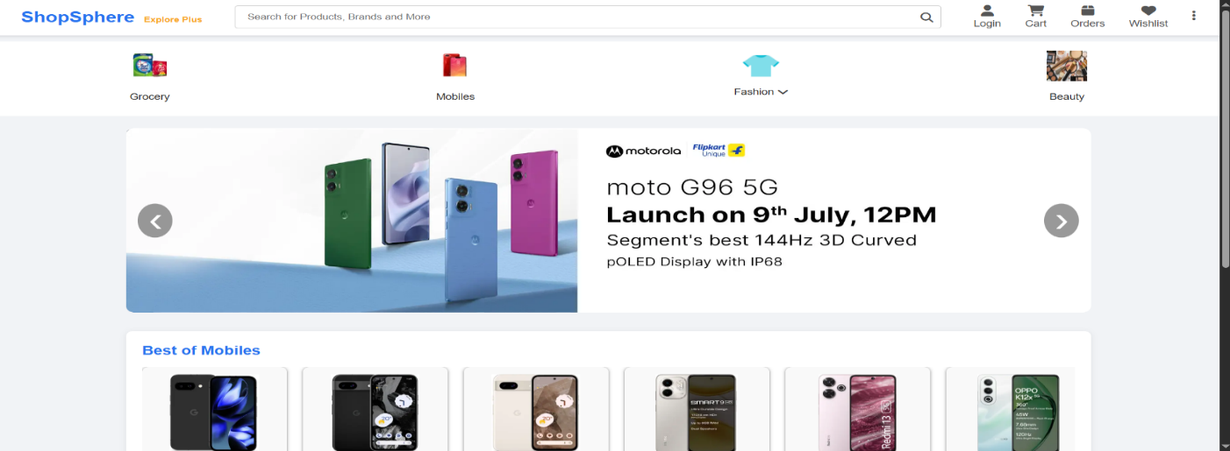  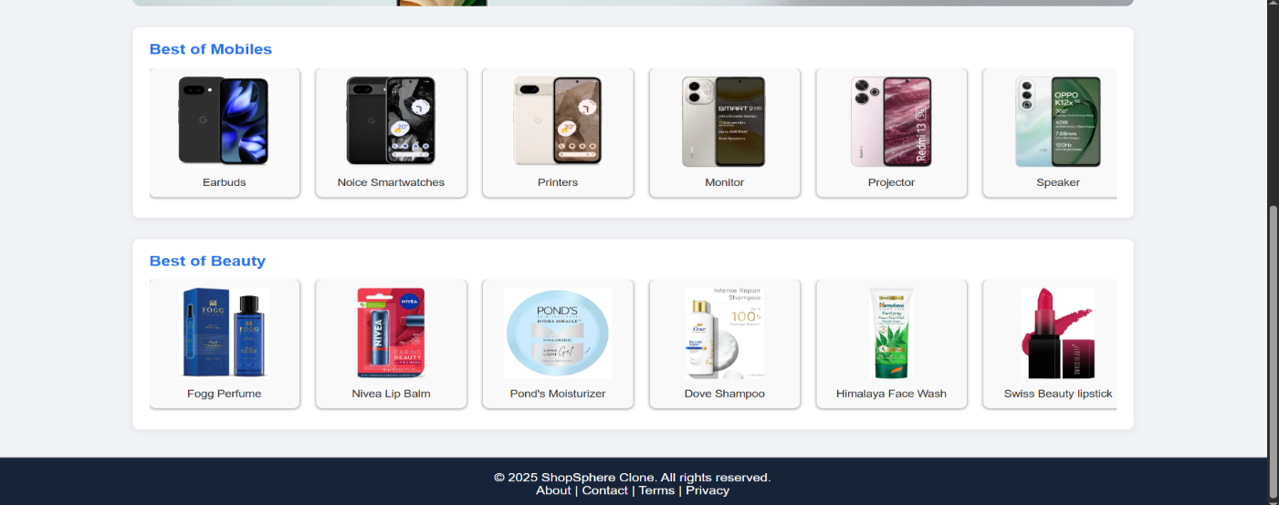  Login  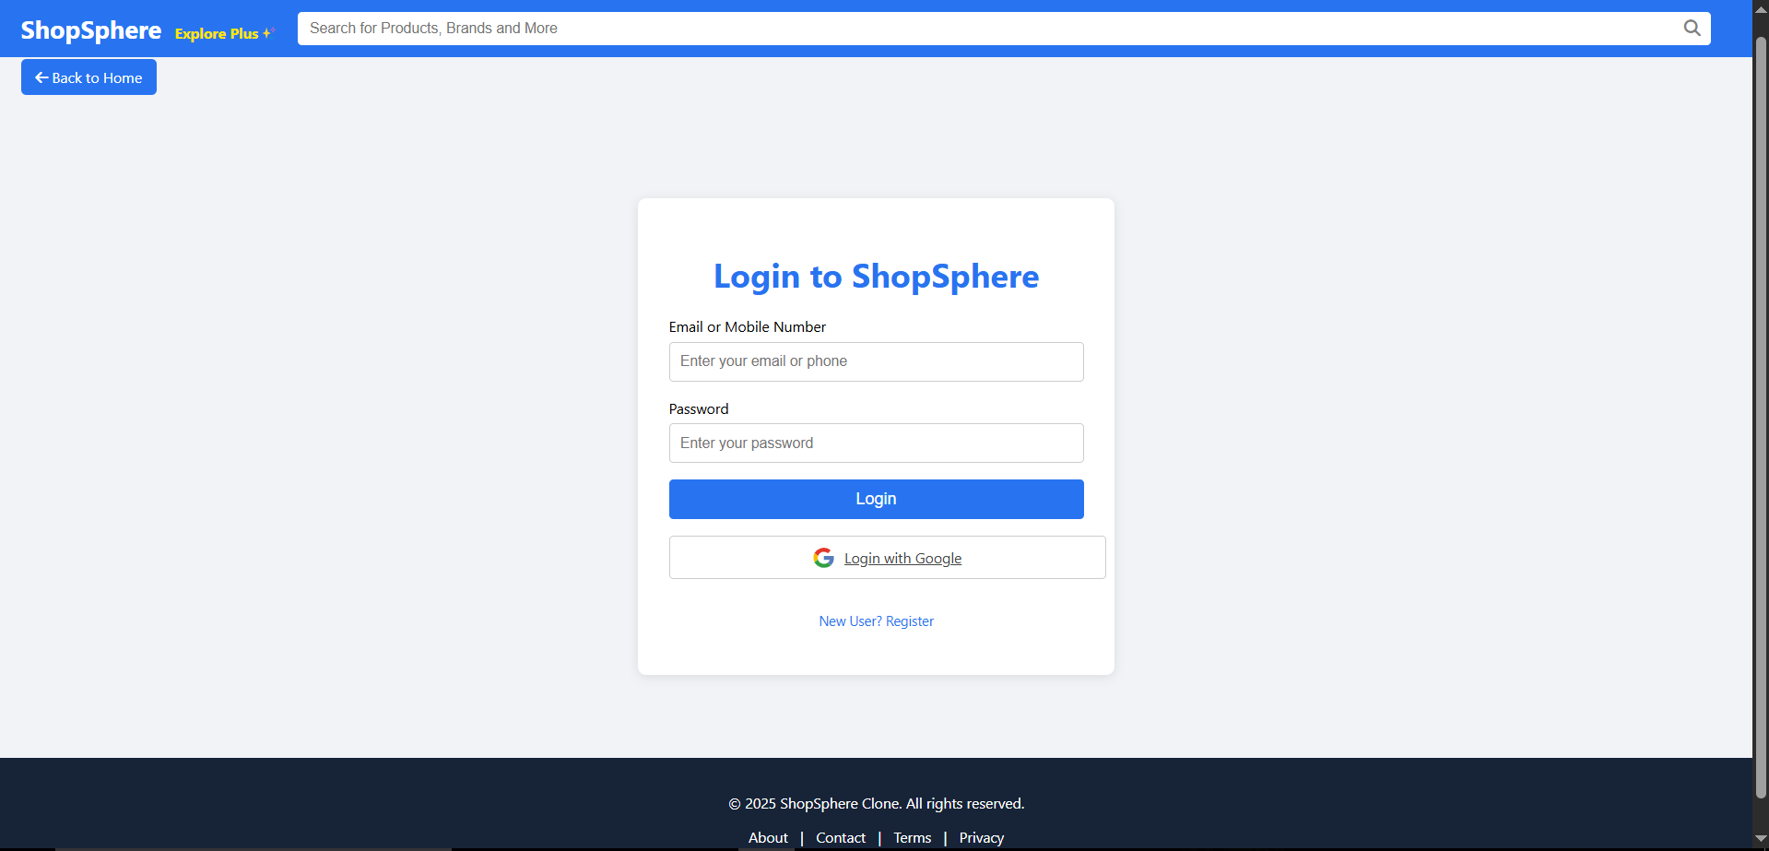  Orders  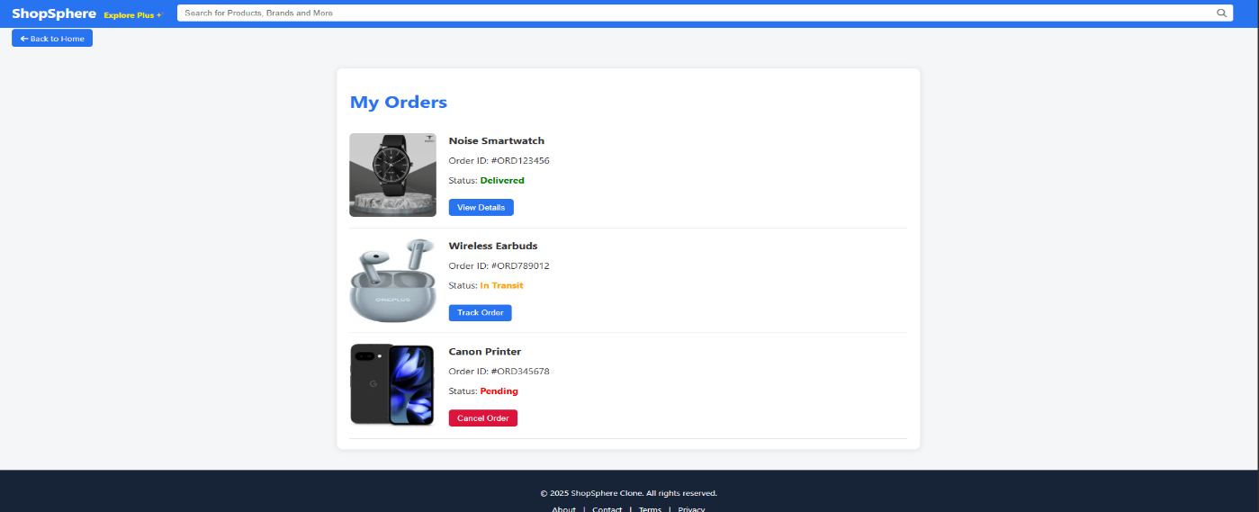  Privacy  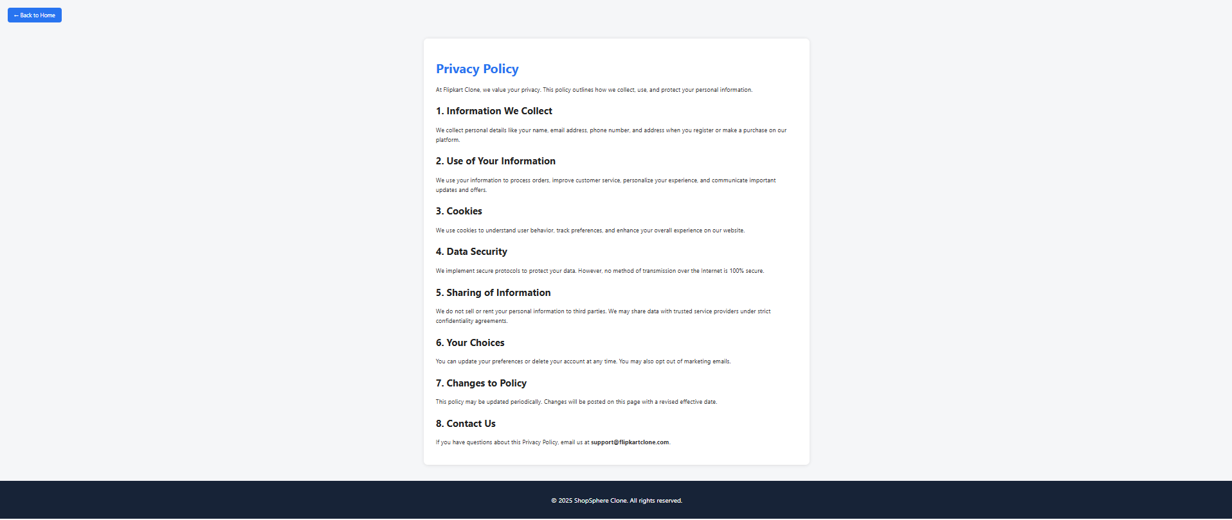  Register  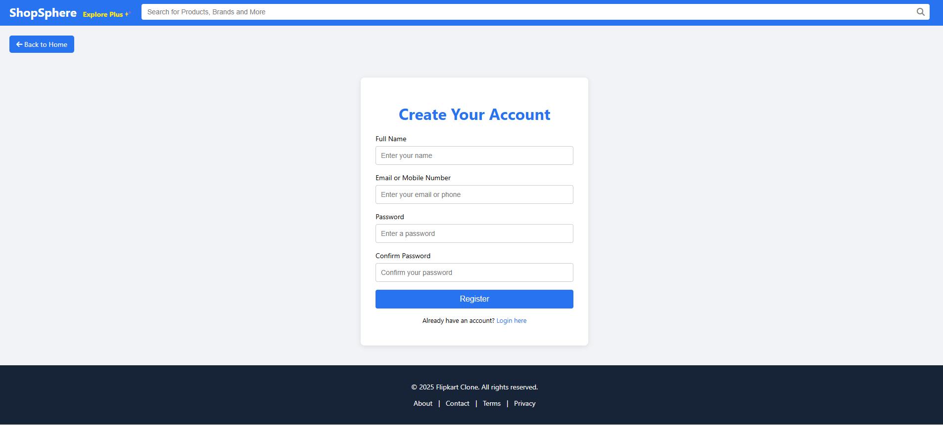  Wishlist  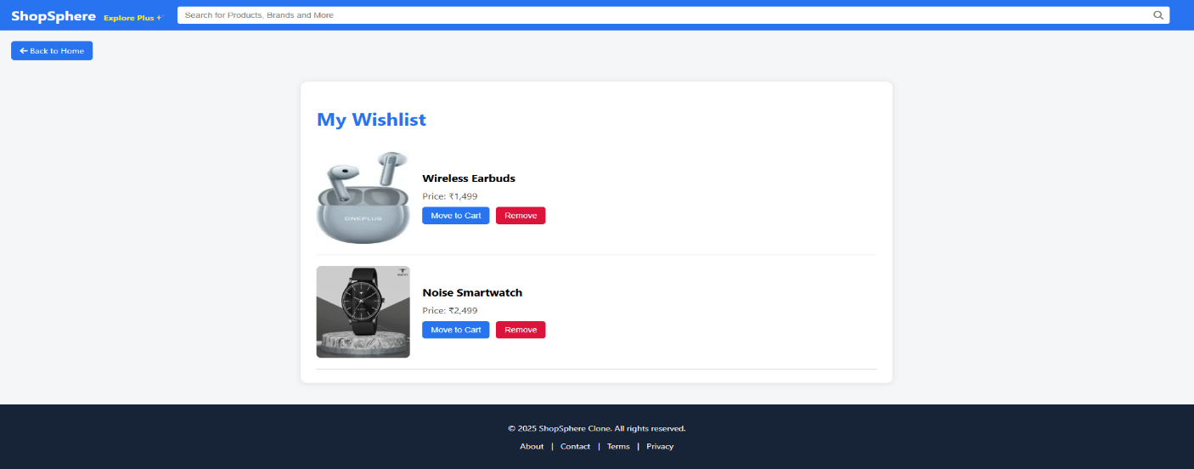  Women  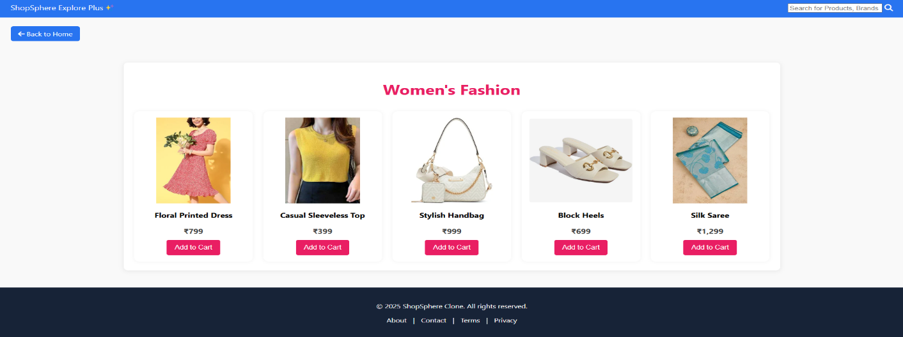  Men  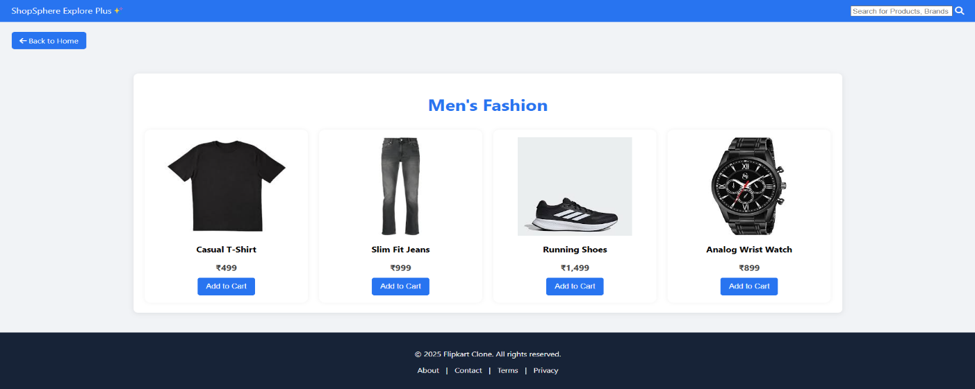  Mobiles  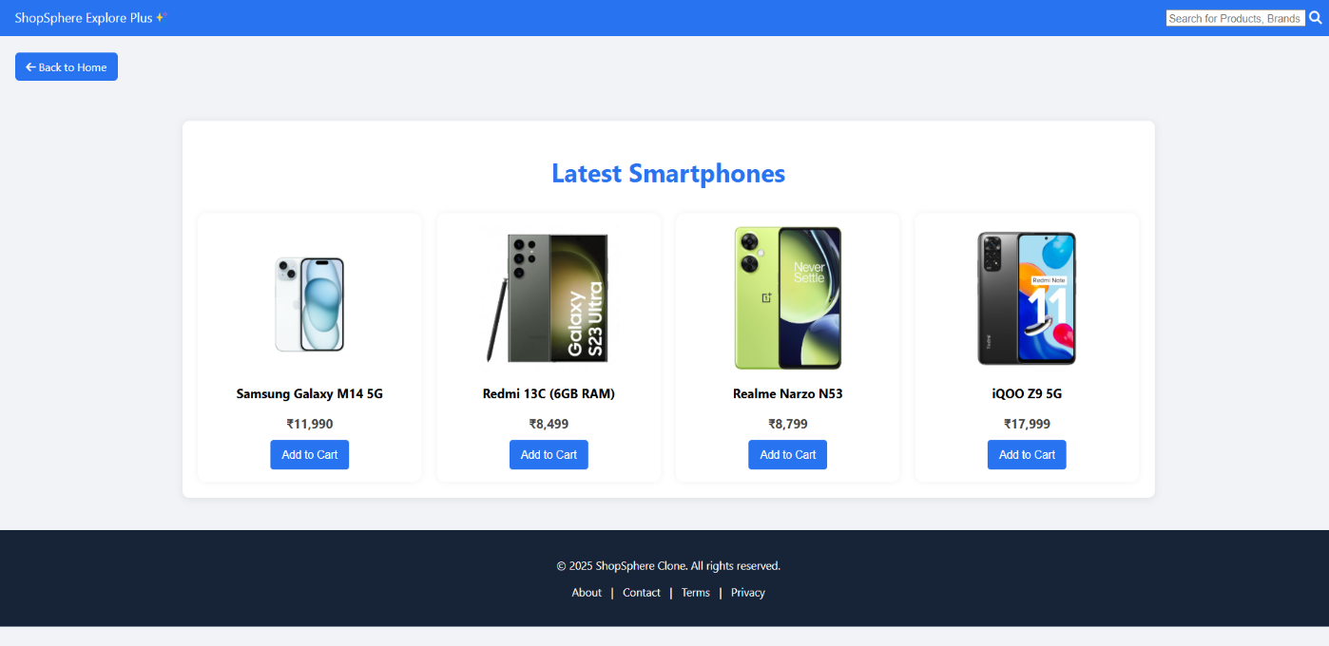  Grocery  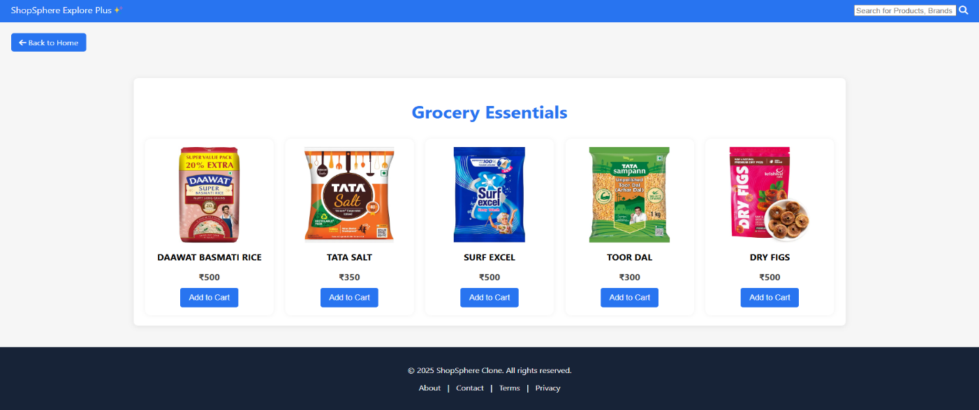  Customer Care  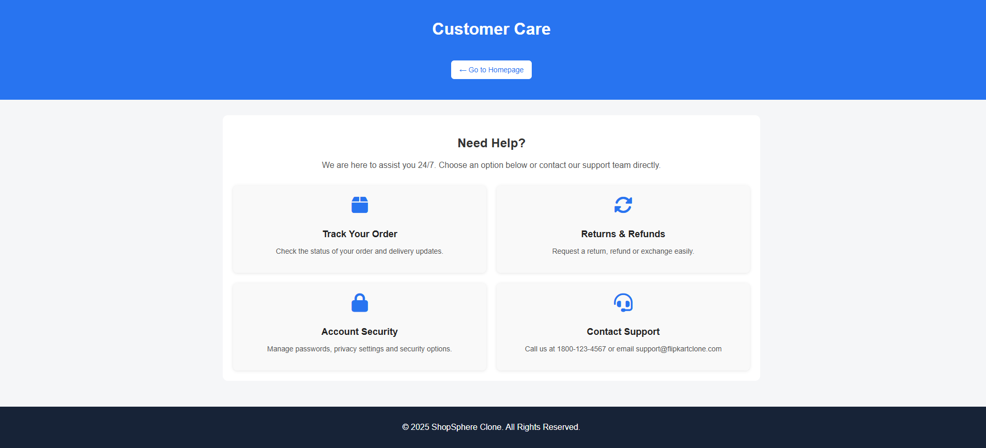  Contact Us  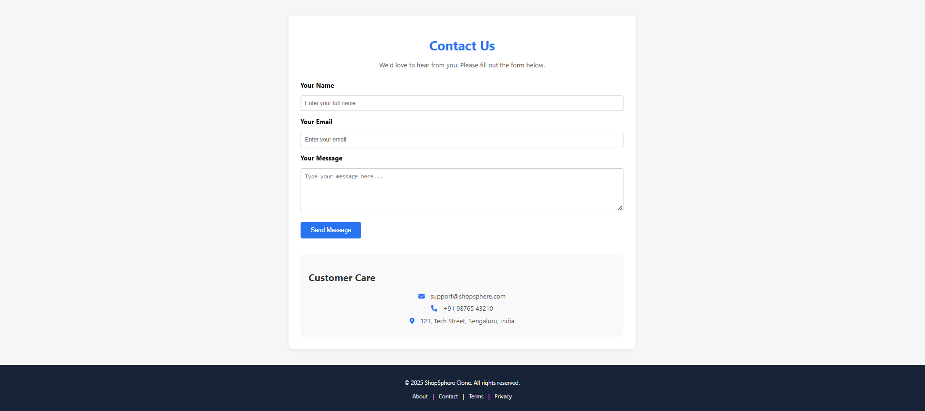  Cart  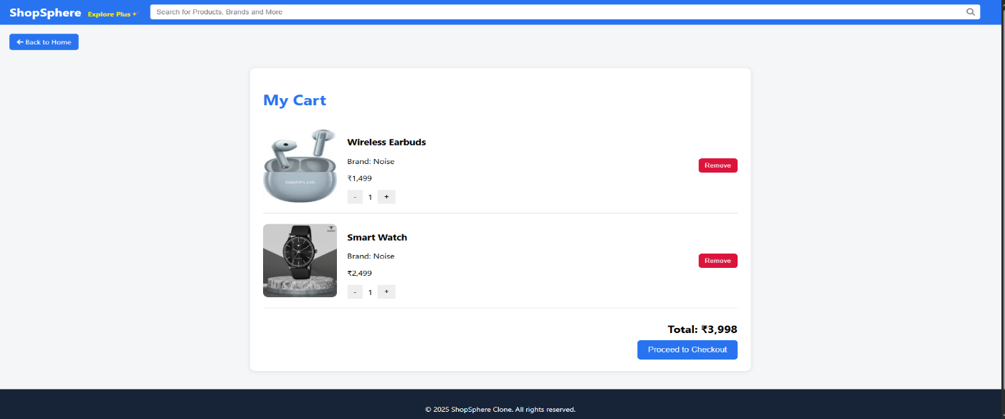  Beauty  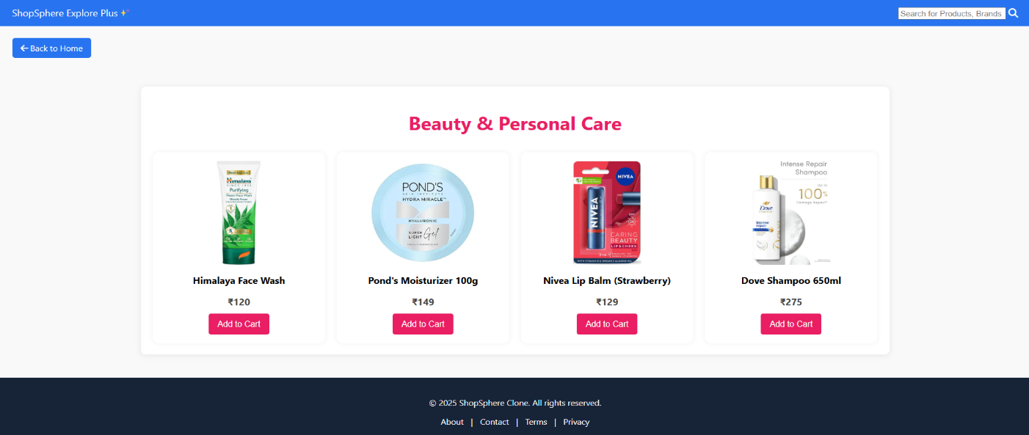  About Us  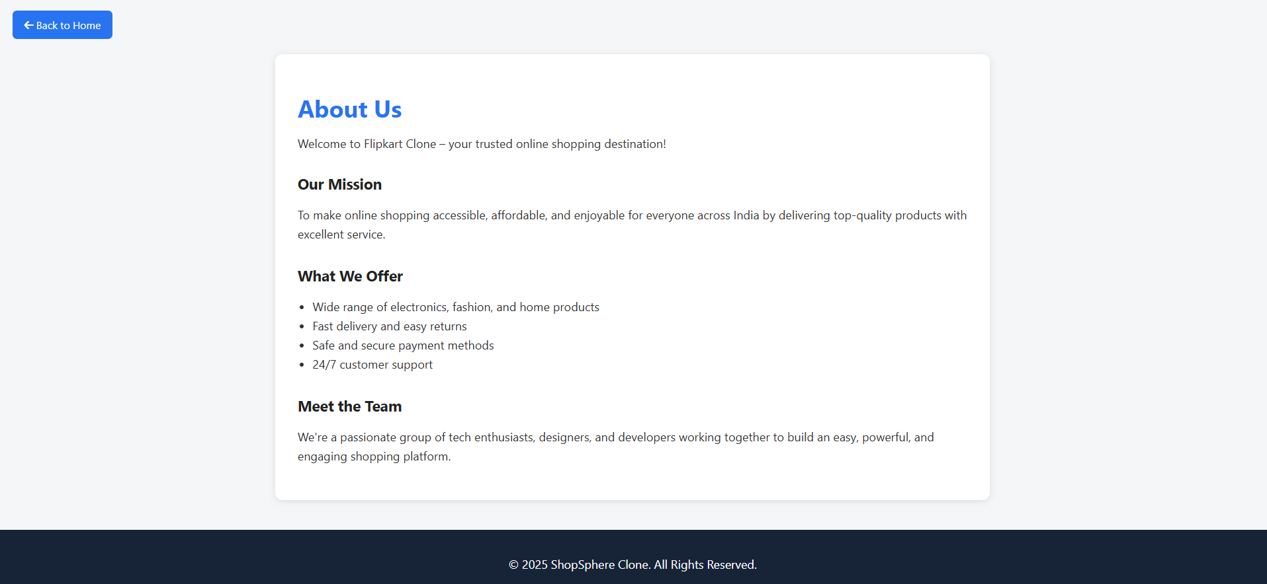  Terms  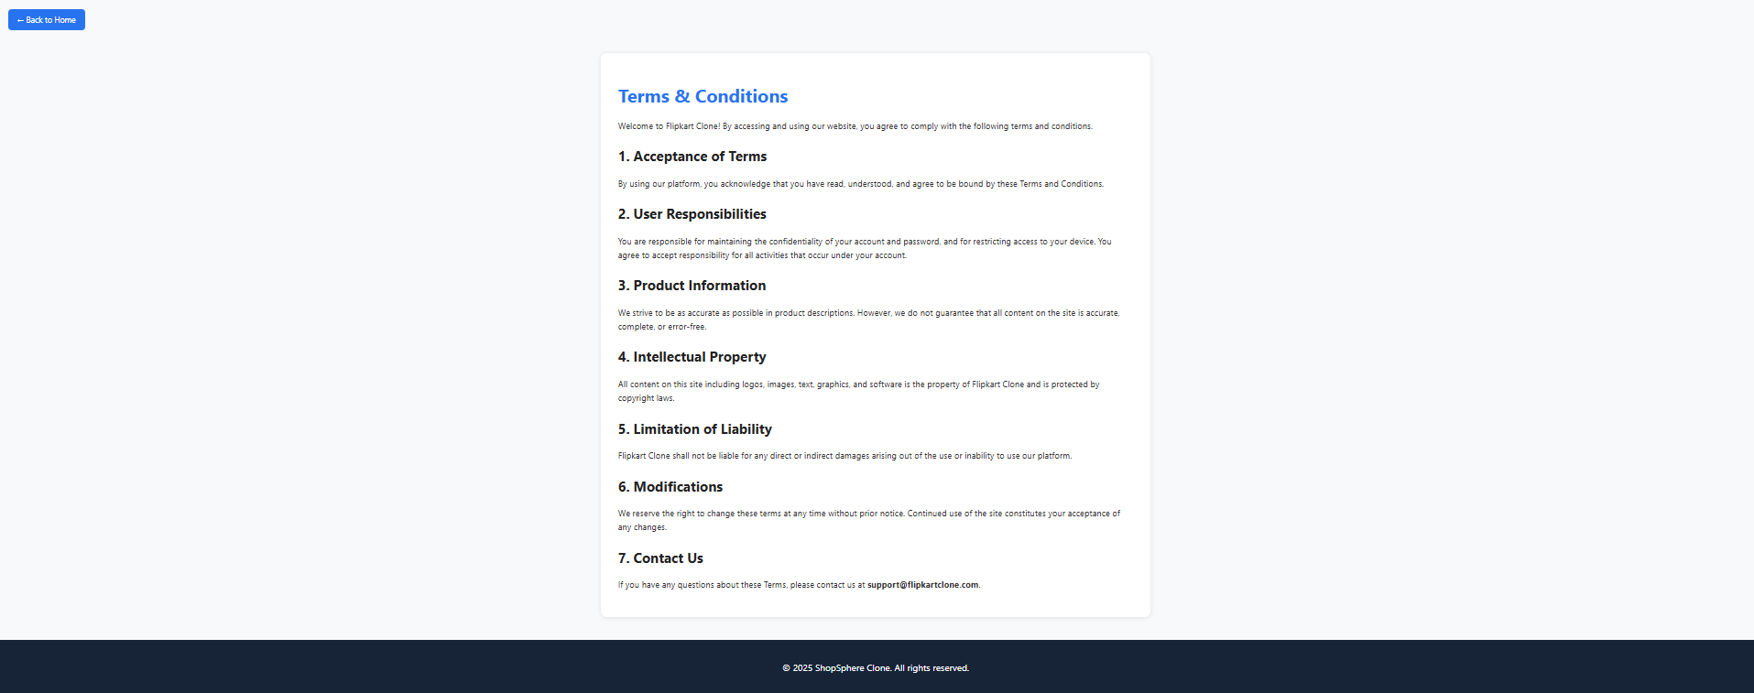  Payment  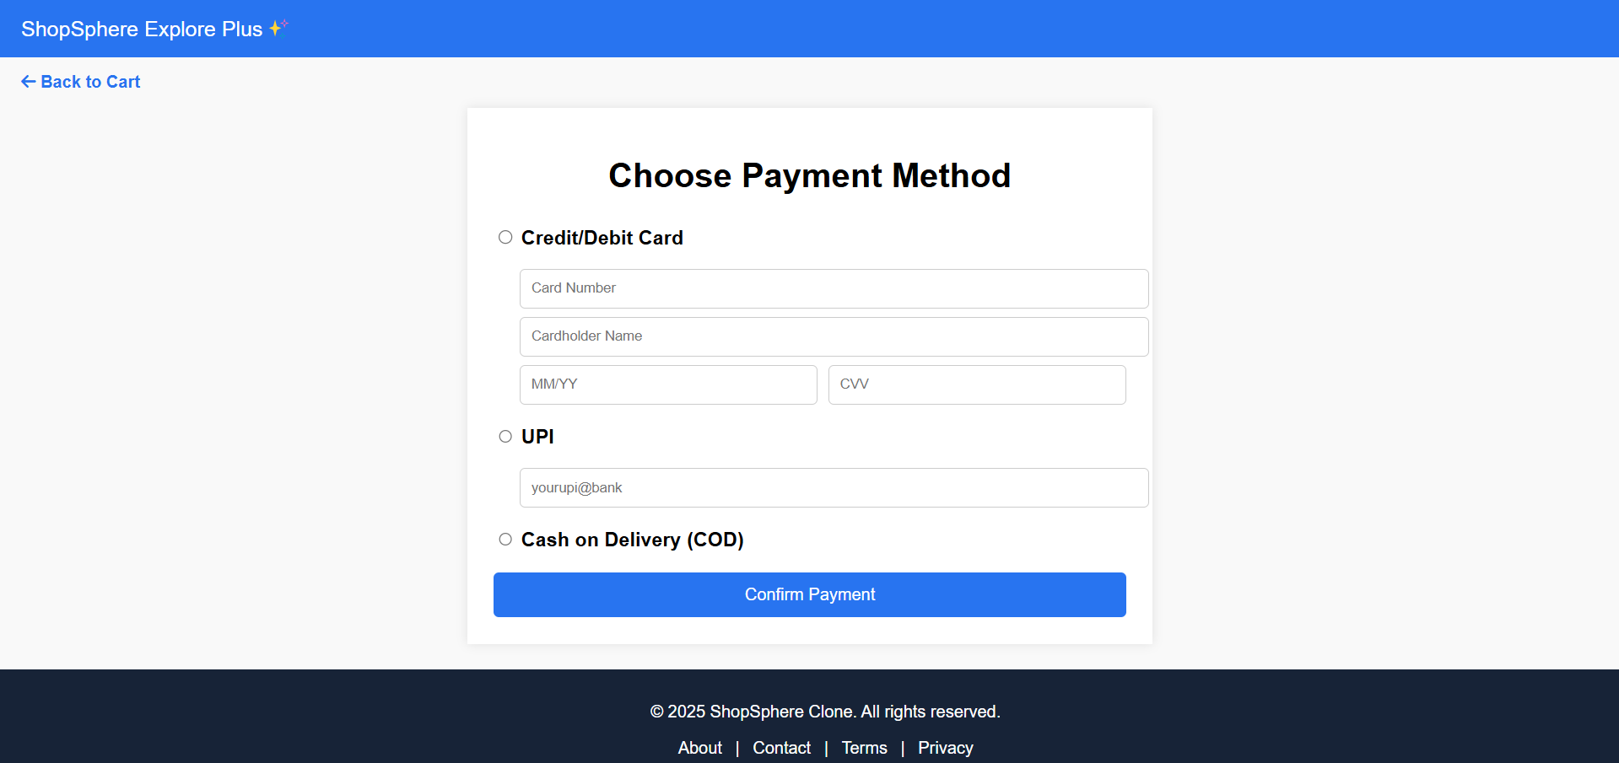  CONCLUSION:  In this practical, fully responsive layouts were created for the Home, About, and Registration pages using CSS Flexbox and Grid. This ensures a modern and professional look for any web portal.

No. | Aim of the Practical
3. | Create a user registration page with frontend validation using HTML5 and  JavaScript.  PROGRAM CODE:  document.getElementById("registerForm").addEventListener("submit", function (e) {  e.preventDefault();  const name = document.getElementById("name").value.trim();  const email = document.getElementById("email").value.trim();  const password = document.getElementById("password").value;  const confirmPassword= document.getElementById("confirm-password").value;  // Name validation  if (name.length < 3) {  alert("Please enter a valid name (minimum 3 characters).");  return;  }  // Email or Mobile validation  const emailRegex = /^[^\s@]+@[^\s@]+\.[^\s@]+$/;  const phoneRegex = /^[6-9]\d{9}$/;  if (!emailRegex.test(email) && !phoneRegex.test(email)) {  alert("Please enter a valid email or mobile number.");  return;  }  // Password strength validation  const passwordRegex = /^(?=.*[A-Z])(?=.*\d)(?=.*[@$!%*?&])[A-Za-z\d@$!%*?&]{8,}$/;  if (!passwordRegex.test(password)) {  alert("Password must be at least 8 characters long and include at least one uppercase letter, one digit, and one special character.");  return;  }  // Confirm password match  if (password !== confirmPassword) {  alert("Passwords do not match.");  return;  }  // Success  alert("Registration successful!");  window.location.href = "login.html";  });  OUTPUT:  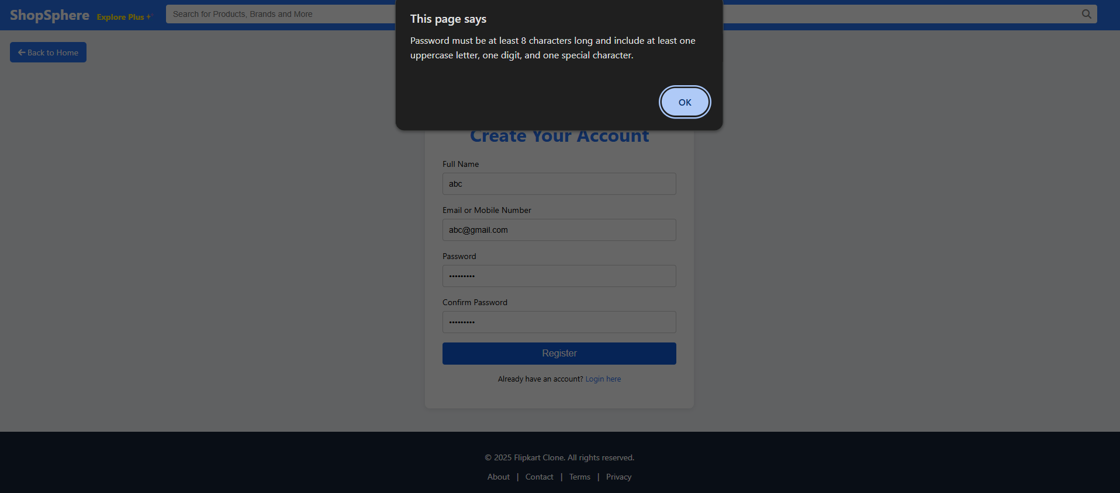  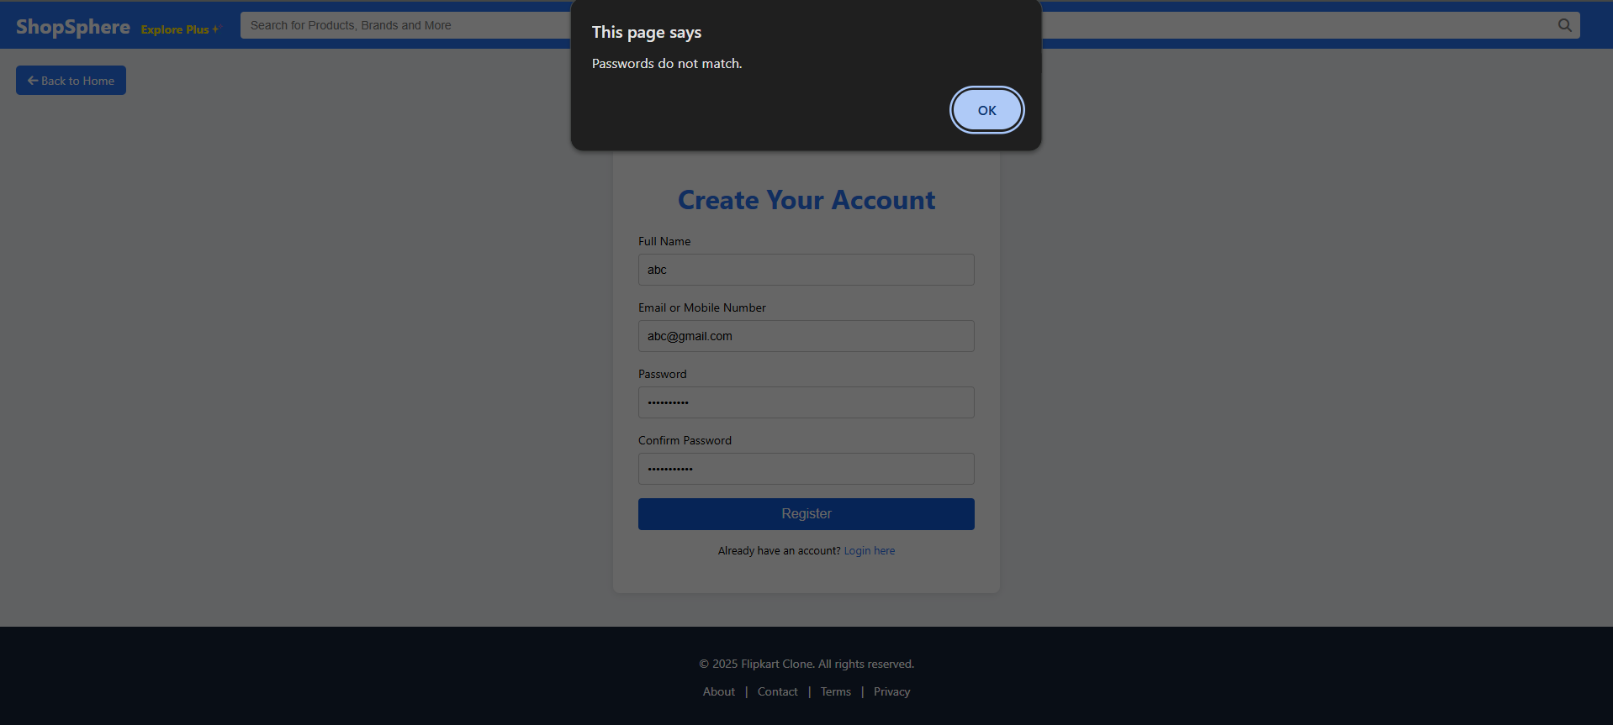  CONCLUSION:  In this practical, we successfully created a user registration page that includes frontend validation using HTML5 and JavaScript. HTML5 input attributes like required, type, minlength, and pattern provided basic validation, while JavaScript was used to add custom checks such as password match, email format, and real-time error messages. This enhances the user experience, prevents incorrect data submission, and reduces server load by catching errors early at the client side.

No. | Aim of the Practical
4. | Create dynamic content such as collapsible FAQs, popups, and sliders in portal  pages.  PROGRAM CODE:  Home page:  let slideIndex = 0;  const slides = document.querySelectorAll('.slide');  const totalSlides = slides.length;  // Show the current slide  function showSlide(index) {  slides.forEach(slide => slide.classList.remove('active'));  slides[index].classList.add('active');  }  // Auto-slide every 3s  function autoSlide() {  slideIndex = (slideIndex + 1) % totalSlides;  showSlide(slideIndex);  }  // Manual slide control  function changeSlide(n) {  slideIndex = (slideIndex + n + totalSlides) % totalSlides;  showSlide(slideIndex);  }  // Initialize first slide  showSlide(slideIndex);  setInterval(autoSlide, 3000);  //Dropdown three dots  const menuToggle = document.getElementById("menuToggle");  const dropdownMenu = document.getElementById("dropdownMenu");  menuToggle.addEventListener("click", function (e) {  e.stopPropagation(); // prevent bubbling  dropdownMenu.classList.toggle("show");  });  // Close dropdown if clicking outside  document.addEventListener("click", function (e) {  if (!menuToggle.contains(e.target)) {  dropdownMenu.classList.remove("show");  }  });  // Optional: Dark mode toggle  document.getElementById("darkToggle").addEventListener("change", function () {  document.body.classList.toggle("dark", this.checked);  });  //Category row dropdown  const fashionToggle = document.getElementById("fashionToggle");  const fashionMenu = document.getElementById("fashionMenu");  fashionToggle.addEventListener("click", function (e) {  e.stopPropagation(); // Prevent closing immediately  fashionMenu.classList.toggle("show");  });  // Close dropdown when clicking outside  document.addEventListener("click", function (e) {  if (!fashionToggle.contains(e.target)) {  fashionMenu.classList.remove("show");  }  });  Cart:  document.addEventListener("DOMContentLoaded", function () {  const cartContainer = document.querySelector(".cart-container");  const totalElement = document.querySelector(".cart-summary h2");  const checkoutBtn = document.querySelector(".checkout-btn");  function updateTotal() {  const cartItems = document.querySelectorAll(".cart-item");  let total = 0;  cartItems.forEach(item => {  const priceText = item.querySelector(".item-info p:nth-of-type(2)").textContent;  const price = parseFloat(priceText.replace("₹", "").replace(",", ""));  const qty = parseInt(item.querySelector(".qty span").textContent);  total += price * qty;  });  totalElement.textContent = `Total: ₹${total.toLocaleString("en-IN")}`;  // Disable checkout if no items  if (cartItems.length === 0) {  document.querySelector(".cart-summary").innerHTML = `  <h2>Your cart is empty</h2>  <a href="homepage.html" class="checkout-btn">Continue Shopping</a>  `;  }  }  document.querySelectorAll(".cart-item").forEach(item => {  const qtySpan = item.querySelector(".qty span");  const minusBtn = item.querySelector(".qty button:first-child");  const plusBtn = item.querySelector(".qty button:last-child");  const removeBtn = item.querySelector(".remove-btn");  plusBtn.addEventListener("click", () => {  let qty = parseInt(qtySpan.textContent);  qtySpan.textContent = qty + 1;  updateTotal();  });  minusBtn.addEventListener("click", () => {  let qty = parseInt(qtySpan.textContent);  if (qty > 1) {  qtySpan.textContent = qty - 1;  updateTotal();  }  });  removeBtn.addEventListener("click", () => {  item.remove();  updateTotal();  });  });  checkoutBtn.addEventListener("click", () => {  const cartItems = document.querySelectorAll(".cart-item");  if (cartItems.length === 0) {  alert("Your cart is empty!");  return;  }  alert("Thank you for your purchase! Redirecting to payment...");  // You can redirect to a new page like this:  window.location.href = "payment.html"; // or thankyou.html  });  updateTotal();  });  Payment:  document.getElementById("paymentForm").addEventListener("submit", function (e) {  e.preventDefault();  const selected = document.querySelector('input[name="payment"]:checked');  if (!selected) {  alert("Please select a payment method.");  return;  }  const method = selected.value;  // Validation based on selected method  if (method === "card") {  const cardNumber = document.querySelector(".card-details input[placeholder='Card Number']").value.trim();  const cardName = document.querySelector(".card-details input[placeholder='Cardholder Name']").value.trim();  const expiry = document.querySelector(".card-details input[placeholder='MM/YY']").value.trim();  const cvv = document.querySelector(".card-details input[placeholder='CVV']").value.trim();  if (!cardNumber || !cardName || !expiry || !cvv) {  alert("Please fill all card details.");  return;  }  if (!/^\d{16}$/.test(cardNumber.replace(/\s+/g, ''))) {  alert("Please enter a valid 16-digit card number.");  return;  }  if (!/^\d{2}\/\d{2}$/.test(expiry)) {  alert("Enter expiry in MM/YY format.");  return;  }  if (!/^\d{3}$/.test(cvv)) {  alert("Enter a valid 3-digit CVV.");  return;  }  } else if (method === "upi") {  const upiId = document.querySelector(".upi-details input").value.trim();  if (!upiId) {  alert("Please enter your UPI ID.");  return;  }  if (!/^[\w.-]+@[\w.-]+$/.test(upiId)) {  alert("Enter a valid UPI ID (e.g., yourname@bank).");  return;  }  }  // If validations pass  alert("Payment Successful using " + method.toUpperCase() + "!");  window.location.href = "orders.html";  });  OUTPUT:  Home page  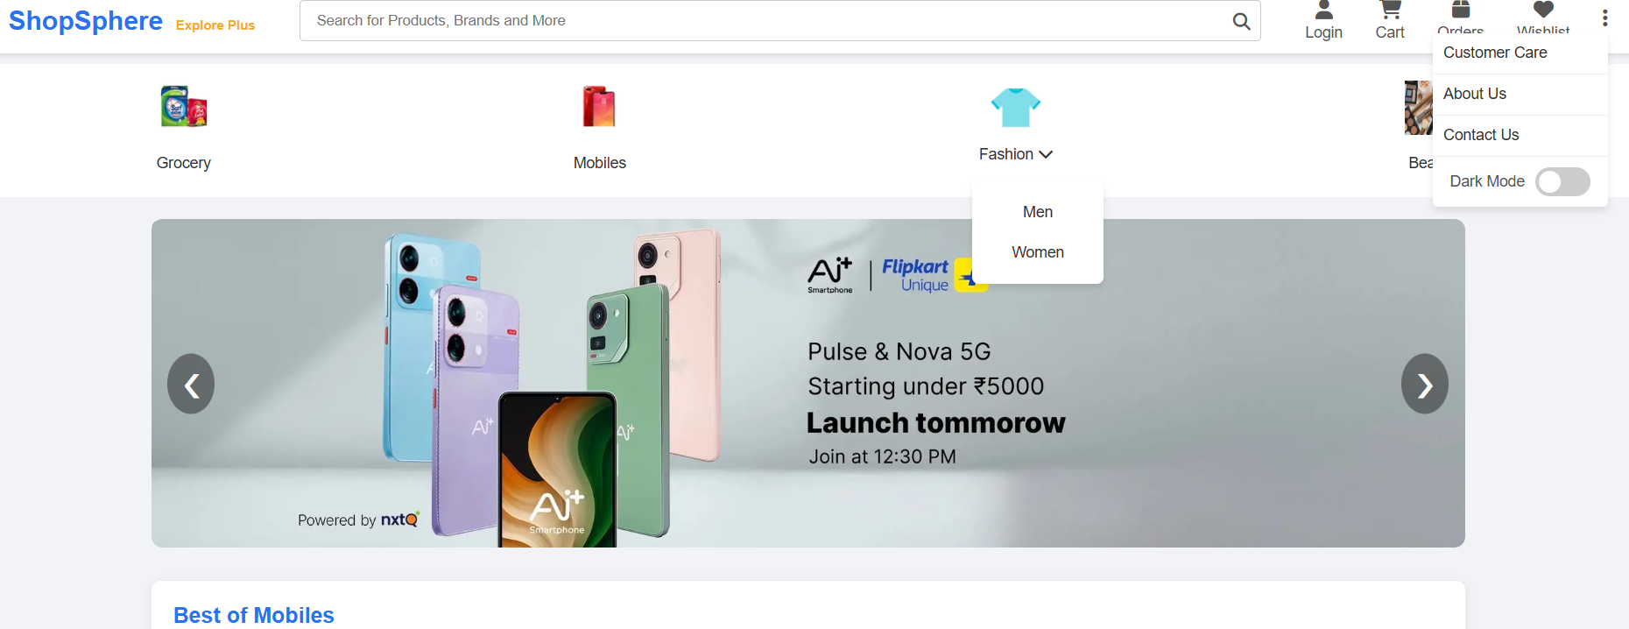  Cart  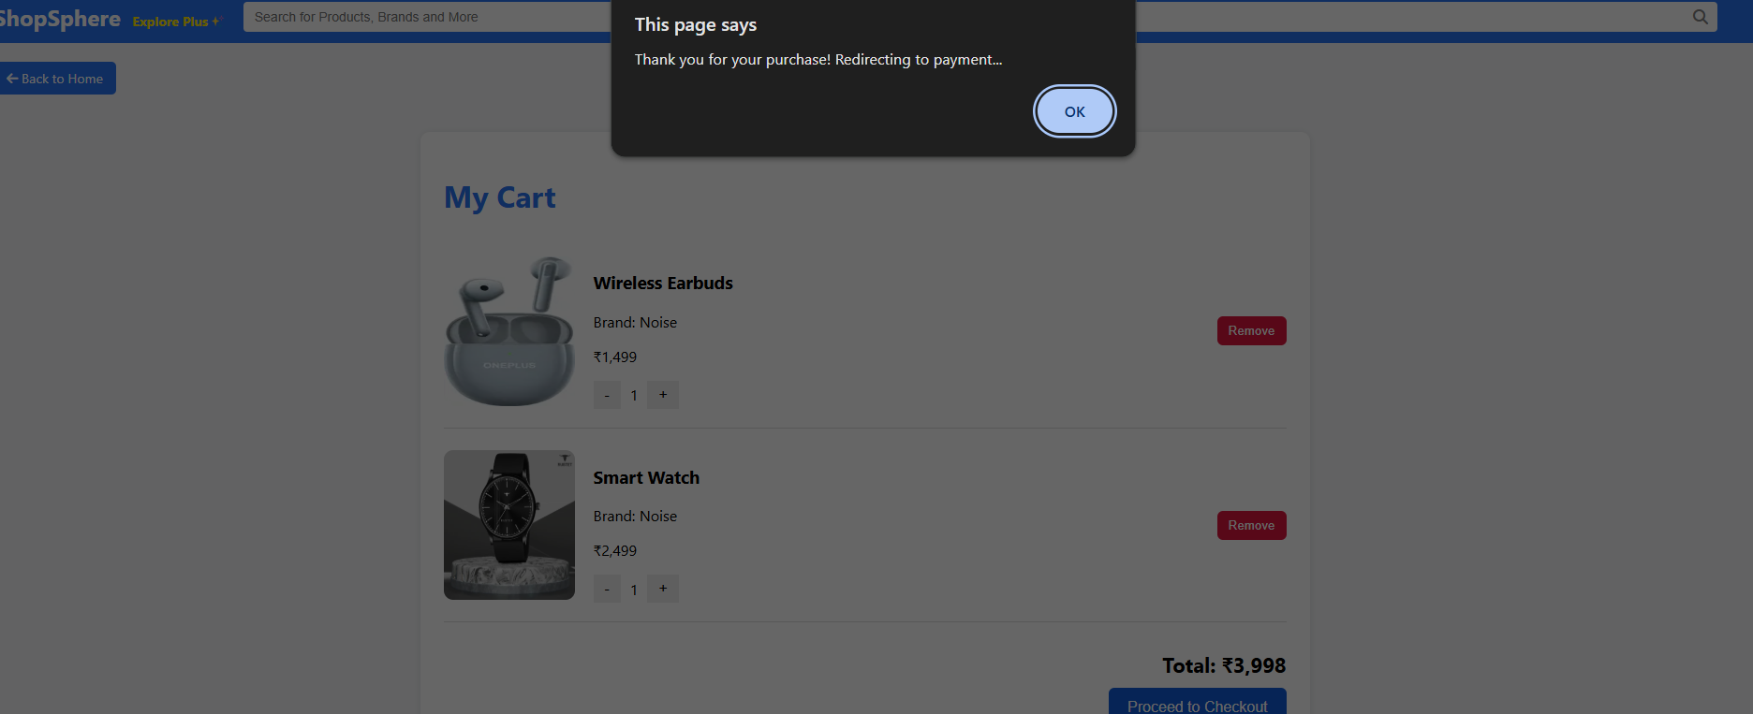  Payment  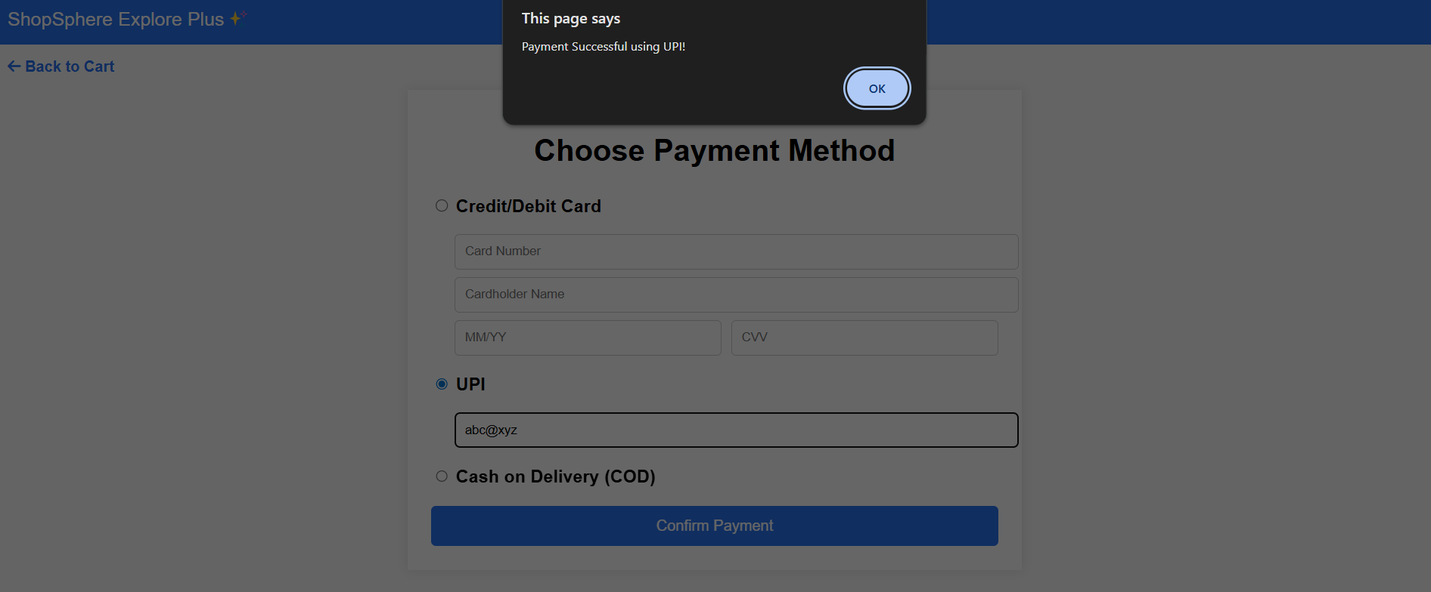  CONCLUSION:  Dynamic elements like collapsible FAQs, popups, and sliders enhance user interaction and engagement on portal pages. They provide a more intuitive, organized, and responsive experience by presenting content in a compact and interactive format, improving both usability and visual appeal.

